The Economic Origins of the Civil War by Marc Egnal
Marc Egnal’s essay on “The Economic Origins of the Civil War” explains how each section modernized in different ways. In this excerpt, Egnal, a history professor at York University in Toronto, argues that the East-West orientation of antebellum Northern commercial traffic helped stoke a sense of free labor nationalism. You can read Egnal’s full essay inside the print edition of Volume 25 of the OAH Magazine of History (April 2011) or online via Oxford Journals.
By the late 1840s the economies of the two sections were evolving. Those changes accelerated the end the era of compromise and prompted a decade of conflict that culminated in civil war. In the North the most important development was the reorientation of trade from its north-south channel along the Mississippi to an east-west axis that included the Great Lakes and the Erie Canal. Shipping along the Mississippi continued to grow. But the commerce that went east-west by lake steamers and canal boats, and after 1855 by railroads, became far greater. Pressing concerns shaped the outlook of those living near the lakes. All the lake ports, including Chicago, Cleveland, Milwaukee, and Buffalo, required extensive federal funds to build piers and dredge their harbors. The Great Lakes have no natural harbors, and the job of keeping ports open — as opponents wryly noted — was endless. Those who relied on the lakes also needed assistance to open several chokepoints tying up commerce, particularly the passages at Sault Ste. Marie and the Saint Clair Flats near Detroit. Recurrent demands for federal outlays made these individuals advocates of higher tariffs because that impost was the chief source of government revenues.
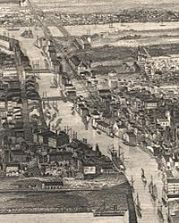
Lake congressmen and their allies in New England defended these requests for funds by waving the banner of nationalism. But it was a nationalism based on “What is good for the Lakes is good for the country.” Chicago representative “Long John” Wentworth (the tallest man in Congress) announced his credo: “I am a national man in every sense of the word…and am growing stronger in the faith every day I live. The commerce of my constituents is that of the whole nation.” New Englanders, who could now sell more shoes and cloth to the West, echoed this sentiment. After Lewis Cass finished a speech on the need for a canal at the eastern end of Lake Superior, Massachusetts Senator John Davis announced his wholehearted support for the project. “I am rejoiced to hear the remarks of the Senator from Michigan,” Davis stated. “He uses exactly the right word when he applies the term ‘national’ to the work for which the appropriation of land was made yesterday.” This self-serving nationalism, fully enunciated by midcentury, would become the ideological basis for Republican policies during the Civil War and the ensuing decades.
Chicago, Illinois, 1856

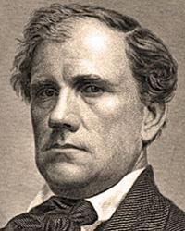

John Wentworth

The Political Origins of the Civil War by Jonathan Earle
Jonathan Earle’s essay on “The Political Origins of the Civil War” argues that politics, not slavery, caused the secession crisis. He explains why Abraham Lincoln’s election in 1860 triggered such a catastrophic response among some Southerners. In this excerpt below, Earle, a history professor at the University of Kansas, describes how John Brown’s 1859 raid at Harpers Ferry contributed to the polarized political climate. You can find the full essay inside the print edition of Volume 25 of the OAH Magazine of History (April 2011) or online via Oxford Journals.
The election of 1860 showed just how frayed the nation’s political system had become after a decade of uninterrupted sectional turmoil, and how unlikely a Henry Clay – style grand compromise would be at the start of the new decade. The campaign had barely gotten underway when John Brown resurfaced by invading the slave state of Virginia and occupying the federal arsenal at Harpers Ferry in October, 1859. The raid was over just thirty-six hours after it had begun, and Brown and six of his surviving followers were hastily convicted and sentenced to hang after a sensational trial in Charles Town, Virginia. Harpers Ferry polarized the United States as no previous event ever had, and set in motion a dizzying spiral of actions and reactions. At the start of 1860, the raid and some Northerners’ responses to it threatened to cost the Republican Party at the polls. “ The quicker they hang him and get him out of the way, the better, ” said Republican Charles H. Ray. “ We are damnably exercised here about the effect of Old Brown’s retched fiasco . . . upon the moral health of the Republican Party! ”
In the South, newspapers declared that Brown’s actions were simply the logical (and inevitable) outcome of Republican agitation over slavery restriction. The Baltimore Sun, heretofore the voice of border state moderation, announced that the South could not afford to “live under a government, the majority of whose subjects or citizens regard John Brown as a martyr and a Christian hero, rather than a murderer and a robber” Time and again, Southern criticism fell on those considered more “radical” opponents of slavery, men like William H. Seward and Horace Greeley. “Brown may be insane,” wrote the editor of the Richmond Enquirer, “but there are other criminals, guilty wretches, who instigated the crime perpetrated at Harpers Ferry ... bring Seward, Greeley, Hale, and Smith to the jurisdiction of Virginia and Brown and his deluded victims in the Charlestown [sic] jail may hope for a pardon.” Suddenly the political futures of Republicans not heretofore known as “radicals,” men like Abraham Lincoln, were looking up.

John Brown, circa 1857 Brown on the steps of the
scaffold, Dec. 2, 1859
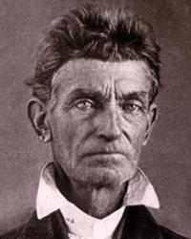
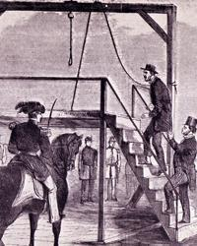

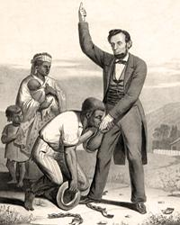
Slavery, the Constitution, and the Origins of the Civil War by Paul Finkelman
Paul Finkelman’s essay on “Slavery, the Constitution, and the Origins of the Civil War” describes the slow-developing constitutional collision over slavery that began in 1787 and finally erupted into war by 1861. This excerpt, however, focuses on Lincoln’s emancipation policy and argues that the “irony” of southern secession was how it “allowed Lincoln to do what he had always wanted.” Finkelman, a law professor at the University of Albany, considers Lincoln deeply opposed to slavery and yet also committed to upholding the Constitution and political compromises over slavery during the years before war broke out. You can read Finkelman’s full essay inside the print edition of Volume 25 of the OAH Magazine of History (April 2011) or online via Oxford Journals.
Thus, when it came to ending slavery inside the United States, Lincoln and Congress narrowly hewed to the constitutional understandings that had existed before the war. The slaves in the Confederacy, however, were another matter. They were property, used by the enemies of the United States to make war on the United States. Furthermore, the Constitution could not be applied in the Confederate states. There was no “law” there anymore, except martial law and the law of war. Under that theory, General Butler declared runaway slaves to be contrabands of war, and thus legitimately seized and freed. Congress did the same in both Confiscation Acts and in other laws and regulations. Lincoln followed suit in the Emancipation Proclamation, narrowly limiting it to those places that were still at war and not under national jurisdiction. Significantly, Lincoln issued the proclamation “by virtue of the power in me vested as Commander-in-Chief of the Army and Navy of the United States in time of actual armed rebellion.”
This was, constitutionally, a war measure designed to cripple the ability of those in rebellion to resist the lawful authority of the United States. It applied only to those states and parts of states that were still in rebellion. This was constitutionally essential. The purpose of the proclamation was “restoring the constitutional relations” between the nation and all the states. The irony of secession was that it allowed Lincoln to do what he had always wanted. He had always believed slavery was wrong and immoral. But, as a lawyer, a Congressman, and an incoming president he understood that the national government could only regulate or end slavery in the District of Columbia and the territories. In a famous letter published in the New York Tribune, Lincoln repeated his “oft-expressed personal wish that all men everywhere could be free.” He later told a correspondent, “If slavery is not wrong, nothing is wrong.” Without secession, however, he could never have acted on these personal views, because, as he told the South in his first inaugural address, the Constitution guaranteed their property rights in slaves. But, once the slave states abandoned the Constitution, they could no longer expect it to protect them.

