Period 8 Overview: 1945-1980
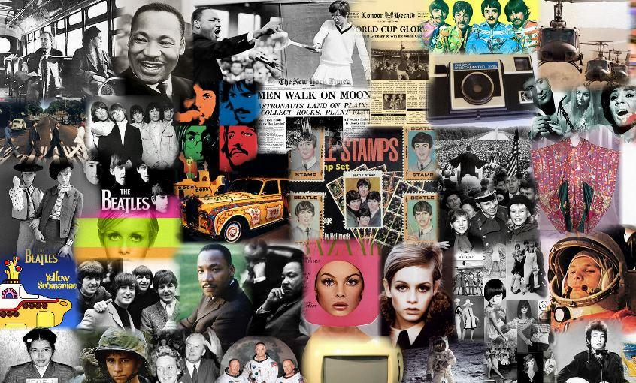
Overview In 1945, the United States emerged from World War II with the world's largest and strongest economy. Despite fears of a return to an economic depression, Americans were happy to get back to civilian life. Suburbanization, prosperity, and conformity during the 1950’s soon gave way to a growing civil rights movement and an unpopular war in Vietnam, foreshadowing a period of turbulence, protest, and disillusionment. What no one could predict was how the fall of colonial empires, the spread of Communism, technological changes, a growing conservative impulse, and an emerging global economy would impact American lives in the future.

Beginning = Victory in World War II and the rise of America as a global superpower

What do I need to know?
1. The various methods used to try to CONTAIN (George Kennan) Communism
a. Examples: Truman Doctrine ($ to Greece and Turkey), Marshall Plan ($ to European countries to rebuild), NATO (first permanent peacetime alliance), Korean War (United Nations), Vietnam War
2. The relation between U.S and the Soviet Union fluctuated between hostility and “détente”
a. Examples of conflict: Berlin Blockade & Airlift, Warsaw Pact, NSA­‐68, Mutually Assured Destruction, Cuban Missile Crisis, U­‐2 Crisis, Korean War, Vietnam War
b. Examples of détente: Geneva Convention, United Nations, SALT Treaties, Nixon goes to China
3. Ways the U.S. supported undemocratic governments, so long as they were not Communist
a. CIA in Iran and Guatemala, Support for the Diem regime in Vietnam, support for Augusto Pinochet in Chile
4. Cold War led to conflict at home between liberty & order, war & peace
a. Examples:
i. Order vs. Liberty: 2nd Red Scare (compare/contrast to 1920’s Red Scare), HUAC, McCarthyism, Alger Hiss, Rosenbergs
ii. Arms Race & Space Race: Ike’s “Military/Industrial Complex”, Sputnik, NASA, increase $ for science education, H­‐Bomb
iii. Rise of anti­‐war Movement: Anti­‐Vietnam War 1968, Tet Offensive, Bombing Cambodia, My Lai Massacre, college protests (Kent State, Berkeley, Michigan St.)
5. The Supreme Court’s Brown vs. Board of Education decision in 1954 began the Civil Rights movement while also leading white southerners to close ranks around their racial order
a. Examples: Brown v. Board, Montgomery Bus Boycott 1955­‐56, Freedom Riders 1961, Freedom Summer 1964
b. How federal government acted to encourage an end to Jim Crow
i. Executive Branch: Truman desegregates military 1948, LBJ’s Great Society
ii. Legislative: Civil Rights Act of 1964, Voting Rights Act 1965
iii. Judicial: Brown vs. Board Warren Court expanded rights of the accused (liberal court)
iv. Southern White Reaction: Closed ranks/white supremacy: Southern Manifesto, Little Rock 9, “Solid South”, George Wallace “Segregation Now, Segregation Forever”, KKK (3rd Gen)
6. The Civil Rights Movement was radicalized after 1968 deaths of RFK and Martin Luther King, Jr.
a. Stokely Carmichael, “Black Power”, Malcolm X, Black Panther
Party
7. Other minority groups were inspired by the success of the Civil
Rights Movement and pressed for their own freedom and equality
a. Examples: Cesar Chavez/Mexican Americans, La Raza, LGBT (Stonewall Riot­‐NYC), American Indian Movement (AIM), Women’s Rights (ERA, Feminine Mystique, National Organization for Women, Roe vs. Wade,)
8. Liberalism under the Great Society (LBJ) continued to expand the power of the federal government (Connect to Progressive Era and New Deal)
a. Examples: Medicare, Medicaid, Poverty programs (Head Start, Job Corps) Civil Rights Act 1964, Voting Rights Act 1965, Immigration Act of 1965 ended Quotas
9. How the Great Society, Warren Court decisions, Hippie Movement, Social change, and rise in sexual and drug experimentation led to a rise in CONSERVATIVE politics (Barry Goldwater­‐1964, Nixon­‐1968, Reagan­‐ 1980)

END= Election of Ronald Reagan in 1980 & rise of conservative revolution

Period Perspectives At home, Americans enjoyed a robust economic growth through the 1960s with little competition, as the rest of world's economies recovered from the war. Democrats, expanding on the New Deal, enacted major domestic programs, such as Medicare, aid to education, and civil rights for African Americans and women. The Cold War against Communist governments dominated U.S. foreign policy. While the threat of the use of nuclear weapons kept the great powers from attacking each other, limited "hot" wars in Korea and Vietnam cost America more than 100,000 lives. By the late 1960s, frustration over the Vietnam War, growing opposition to liberal domestic programs such as civil rights, and increased civil unrest weakened the Democratic majority, which slowly gave way during the 1970s to a conservative resurgence in 1980.
Alternate View Historians debate when postwar prosperity and optimism gave way to pessimism and a declining standard of living for many Americans. Some identify 1968, a year of assassinations, riots, and intense conflict over the Vietnam War as a turning point. Others point to the mid-l970s, when wage growth stagnated for many average Americans.

