Period 3 Overview: 1754-1800
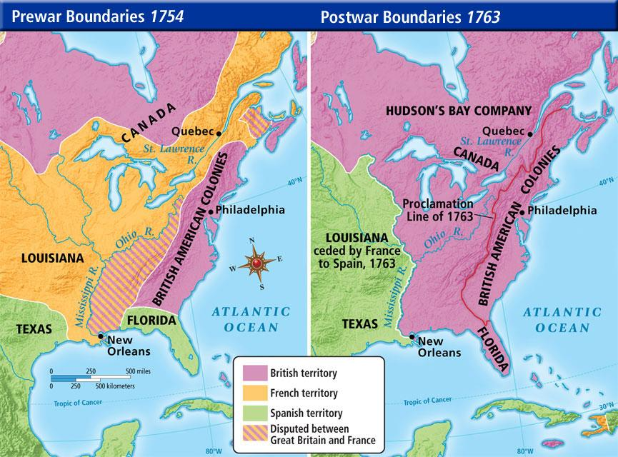
Overview Maneuvering and fighting for control and dominance between Europeans and Native Americans eventually resulted in a global conflict known as the Seven Years or French and Indian War. Following the conclusion of this struggle for imperial control, Britain attempted to reassert control over its colonies, while colonial reaction intensified. In less than fifty years the British went from consolidating its control along the Atlantic coast of North America to watching thirteen of its colonies unite in revolt and establish an independent nation. New experiments with democracy and Republican forms of government amid the rise of growing regional identities led to the formation of political parties, while boundary conflicts led to competition for land resources, increased western migration, and cultural blending.

What do I need to know?

1. How and Why the French and Indian War was a major turning point in US History. Were colonists more “American” or “British”?
a. Examples: End of salutary neglect, Rise of Taxation (Stamp Act, etc.), Resistance to Revolution (Sons of Liberty)
2. Causes and consequences of American Revolution

a. Examples: Pauline Meier, “From Resistance to Revolution” Describe the process, Gordon Wood, “Radicalism of the American Revolution” How radical?
b. Why did colonists win?

3. Compare and Contrast the Articles of Confederation to the Constitution
a. Examples: Land Ordinance, NW Ordinance, Shays’s Rebellion, Weaknesses of AOC, Federalists, Great Compromise, 3/5 Compromise, checks and balances, Whiskey Rebellion
4. Why POLITICAL PARTIES FORMED & regional identities

a. Examples: Hamilton’s economic plans, Jefferson’s agrarian ideology, Washington’s presidency, French Revolution, Washington’s Farewell Address & Foreign Policy Effect

Period Perspectives After the Seven Years' War ended in 1763, the British desired more revenue to pay for protecting their empire while many American colonists saw themselves as self-sufficient. These clashing views resulted in the colonies declaring independence, winning a war and founding a new nation. Initially governed by Articles of Confederation with a weak federal government, the new United States soon replaced it with a new constitution that created a federal government that was stronger, though still with limited powers. Out of the debates over the new constitution and policies emerged two political parties. The test of the stability of the American system came in 1800, when one party, the Federalists, peacefully transferred power to the other, the Democratic Republicans. Throughout this period there was a continuous westward migration resulting in new opportunities, blended cultures, and increased conflicts with the American Indians and other European nations.
Alternate View Some historians start the story of the birth of the United States in 1763, at the end of the Seven Years' War. Starting in 1754 emphasizes that fighting the war drove the colonies and the British apart. While the United States declared independence in 1776 and ratified the Constitution in 1788, not until 1800 had it clearly survived the divisions of the early years.

