Period 5 Overview: 1844-1877
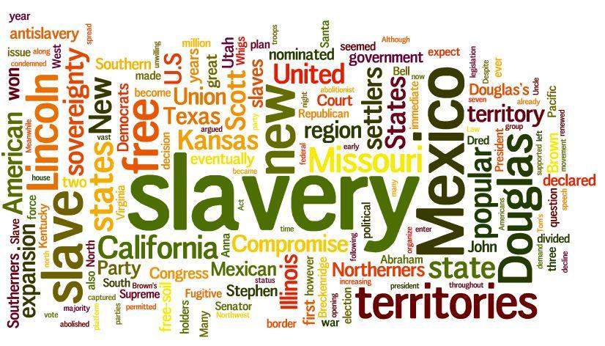
Overview As the young nation grew in population and land, regional tensions centered around the spread of slavery and state’s rights led to a civil war that permanently transformed American society and the nature of the government. Beginning with the election of James Polk in 1844, the United States pursued westward expansion and the opening of new foreign markets. The ideology of “Manifest Destiny” led to a war with Mexico and the acquisition of vast western lands, while intense debates regarding the spread of slavery intensified sectional tensions. After Abraham Lincoln’s election in 1860, the southern states seceded, marking the beginning of the Civil War. After four brutal years of fighting and 500,000 casualties, the Union’s military victory resulted in a contested Reconstruction period and left unresolved many questions about the power of the federal government and citizenship rights.

Beginning = Manifest Destiny, Movement West (Oregon Trail), Election of James K. Polk (Young Hickory)

What do I need to know?
1. The belief in Manifest Destiny led to territorial expansion of the U.S. a. Examples: Texas Revolution, Mexican/American War, Oregon Trail,
California, et
2. How slavery (and attempts at Compromises) ultimately failed to prevent Civil War. What sectional tensions existed (economic, social, political) between the North & South
a. Examples: Wilmot Proviso, Compromise of 1850, Kansas/Nebraska Act, Dred Scott Case, John Brown’s Raids, Election of 1860
3. The North won the Civil War due to a variety of factors (military leaders, industrial capacity, political action, population, resources, key victories) and the war had a devastating impact on the country as a whole (death rates, widows, Sherman’s March, Total War)
a. Examples: Lee vs. McClellan, Emancipation Proclamation, Suspension of Habeas Corpus , Wartime Executive Powers, Antietam, Sherman’s March to the Sea, Gettysburg, Fall of Atlanta, Appomattox Ct. House,
4. How was Reconstruction a failure? How was Reconstruction a success? Did Reconstruction improve the lives of African Americans?
a. Examples: 13th, 14th, 15th Amendments, Radical Republicans, KKK, Jim Crow Laws, Black Codes, Sharecropping, Lincoln’s Second Inaugural Address, Freedmen’s Bureau, Andrew Johnson, Thomas Nast’s Cartoon “Worse Than Slavery”

End = Compromise of 1877 ended Reconstruction – ended 5 military districts, return South to “Home Rule” (Redemption) Lost Cause etc.

Period Perspectives Following a philosophy of manifest destiny, land was added through negotiations, purchase, and war. With victory in the Mexican War, the United States secured its southern border and ports on the Pacific Ocean. Expansion and sectionalism intensified the differences over politics, economics, and slavery. Opposition to slavery ranging from free soilers to abolitionists and an underground railroad grew in spite of fugitive slave laws and the Dred Scott decision. A series of compromises failed and, following the election of Abraham Lincoln in 1860, a civil war ravaged the country.
The Union victory ended the questions of slavery and states' rights. Reconstruction brought confrontations between the executive and legislative branches, and between the federal government and state governments. As the freed African Americans established new lives, Black Codes and sharecropping were established to maintain their subservience.
Alternate View Views of the Civil War have covered a spectrum from an unavoidable conflict over slavery to a failure of leadership and a need­ less bloodletting. Alternate views of Reconstruction considered it a half-done effort that required another 100 years to realize equality for most Americans.

