American History I: Union in Peril and the Civil War Page ___________ Date ___________
EQ: How much do I know about the political, social and economic causes and effects of the American Civil War?
Honors: Civil War Era Theme Park
Hang onto your seats, you’re about to go for a thrilling ride… You have been commissioned with the task of creating a theme park based on the American Civil War. This is a hefty undertaking, one that requires immense knowledge, skill and creativity. Research various elements of the Civil War to create a one-of-a-kind theme park highlighting its many components.
Media Center Time (in class): May 26, 27, 28 Due Date:_____________________
*NO LATE PROJECTS WILL BE ACCEPTED...DON’T DO IT!*
___________________________________________________________________________________
Part I: Give your theme park a catchy name. Be creative. The park’s name should attract visitors from all walks of life. Be sure to display the name prominently in your map/design. (5 points)
Name of Theme Park ______________________________________________________________ ______/5

Part II: Create several sections/zones/lands within your theme park. Most theme parks are divided into smaller sections, such as “Frontier Land” or “Space Zone.” You will create 3 distinct sections built around the following themes: “Minorities in the War,” “Daily Life,” and “Bloody Details.” Feel free to creatively name each section, but stick to the assigned topic.
Minorities  Topic--pick one  - Free Af-Ams (North)  - Enslaved Af-Ams (South)  - Women  - Children  - Other  Creative Name: _________________ | Daily Life/Homefront  Topic--pick one  - Music and Art  - Photography  - Food  - Family Life  - Other  Creative Name: ________________ | Bloody Details  Topic--pick one  - Medicine  - Prisons  - Weaponry  - Spies  - Other  Creative Name: _________________

Part III: Thrilling Rides and Attractions: Each section should include a minimum of 3 rides or attractions relating to the theme of the section. Each ride should include a brief description of ~1 paragraph detailing the specifics of the ride and its historical significance.

Zone Name: ____________________ | Zone Name: ___________________ | Zone Name: ____________________
Ride #1: | Ride #1: | Ride #1:
Ride #2: | Ride #2: | Ride #2:
Ride #3: | Ride #3: | Ride #3:
______/15 _____/15 _____/15

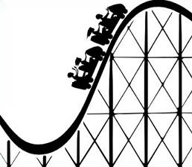 | 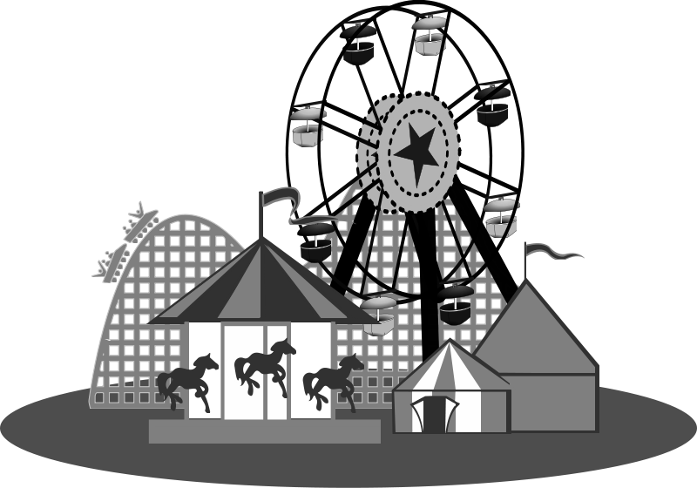

Continued on Back
Part IV: Characters: Every good amusement park has characters roaming about, bringing joy to patrons of all ages. Determine at least 1 character from each section. The characters must be real historical figures and connect to your topic in each theme. Type up an introductory speech for each character. Include a)who they are b)how they relate to the section and c)what a visitor will see upon entering their section of the park. Be sure to give a detailed description of the appearance and costume or create an illustration to serve as a visual for this requirement.
Section 1: ______________________________  Intro. speech with a, b and c. | Section 2: ______________________________  Intro. speech with a, b and c. | Section 3: ______________________________  Intro. speech with a, b and c.
______/5 _____/5 _____/5

Part V:Include a brief advertisement for your park. Where is it located? Why should someone buy a ticket? Major selling points? This can be done as a video, a flyer, or another format approved by your teacher.
Advertisement _____/10 What format will you use? ____________________________________________

Part VI: Product: Your theme park should be colorful and well-labeled. The format of the project is up to you, but must include a visual (map/overall design) that displays the many exciting features of your theme park and the accompanying written descriptions.
Visual: ________/15 Clear, detailed, well-labeled sections/rides (Prezi, poster, 3-D model, park brochure etc.)
What format will you use? ____________________________________________

Part VII: Citations: Required Sources: Minimum of 1 print source(book), one reference item/online encyclopedia
Citations: ______/10 MLA format (Minimum: One Print Source, One Electronic Source)

Citation One:

Citation Two:

*There are many sensitive topics that will arise while researching the Civil War. Make sure that your explanation and illustration of these events is mature and culturally appropriate. If you are unsure about your work/ideas, please ask!

American History I: Union in Peril and the Civil War Page ___________ Date ___________
EQ: How much do I know about the political, social and economic causes and effects of the American Civil War?
Academic: Civil War Era Theme Park
Hang onto your seats, you’re about to go for a thrilling ride… You have been commissioned with the task of creating a theme park based on the American Civil War. This is a hefty undertaking, one that requires immense knowledge, skill and creativity. Research various elements of the Civil War to create a one-of-a-kind theme park highlighting its many components.
Media Center Time (in class): May 26, 27, 28 Due Date:_____________________
*NO LATE PROJECTS WILL BE ACCEPTED...DON’T DO IT!*
_____________________________________________________________________________________
Part I: Give your theme park a catchy name. Be creative. The park’s name should attract visitors from all walks of life. Be sure to display the name prominently in your map/design.
Name of Theme Park ______________________________________________________________ ______/5

Part II: Create several sections within your theme park. Most theme parks are divided into smaller sections, such as “Frontier Land” or “Space Zone.” You will create 2 distinct sections built around the following themes:“Minorities in the War,” “Daily Life,” and “Bloody Details.” Feel free to creatively name each section, but stick to the assigned topic. (Pick 2 of the three themes, and then a topic within each theme)
Minorities  Topic--pick one  - Free Af-Ams (North)  - Enslaved Af-Ams (South)  - Women  - Children  - Other | Daily Life/Homefront  Topic--pick one  - Music and Art  - Photography  - Food  - Family Life  - Other | Bloody Details  Topic--pick one  - Medicine  - Prisons  - Weaponry  - Spies  - Other

Part III: Thrilling Rides and Attractions: Each section should include a minimum of 2 rides or attractions relating to the theme of the section. Each ride should include a brief description of ~1 paragraph detailing the specifics of the ride and its historical significance. (Remember, you are choosing two of the above themes)

Zone Name: ____________________ | Zone Name: ___________________
Ride #1: | Ride #1:
Ride #2: | Ride #2:
Theme #1: _______/20 Theme #2: _______/20

Continued on Back
Part IV: Characters: Every good amusement park has characters roaming about, bringing joy to patrons of all ages. Determine at least 1 character from each zone . The characters must be real historical figures and connect to your topic in each theme. Type up an introductory speech for each character. Include a)who they are b)how they relate to the section and c)what a visitor will see upon entering their section of the park. Be sure to give a detailed description of the appearance and costume or create an illustration to serve as a visual for this requirement.
Section 1: ______________________________  Intro. speech with a, b and c. | Section 2: ______________________________  Intro. speech with a, b and c.
______/5 _____/5

Part V:Include a brief advertisement for your park. Where is it located? Why should someone buy a ticket? Major selling points? This can be done as a video, a flyer, or another format approved by your teacher.
Advertisement _____/10 What format will you use? ____________________________________________

Part VI: Product: Your theme park should be colorful and well-labeled. The format of the project is up to you, but must include a visual (map/overall design) that displays the many exciting features of your theme park and the accompanying written descriptions.
Visual: ________/15 Clear, detailed, well-labeled sections/rides (Prezi, poster, 3-D model, park brochure etc.)
What format will you use? ____________________________________________

Part VII: Citations: Required Sources: Minimum of 1 print source(book), one reference item/online encyclopedia
Citations: ______/10 MLA format (Minimum: One Print Source, One Electronic Source)

Citation One:

Citation Two:

*There are many sensitive topics that will arise while researching the Civil War. Make sure that your explanation and illustration of these events is mature and culturally appropriate. If you are unsure about your work/ideas, please ask!

