AHI: The Civil War Unit 5, Quad #2: Gettysburg Address P _______ D ________

A little background about the Gettysburg Address from the Library of Congress:

Abraham Lincoln was the second speaker on November 19, 1863, at the dedication of the Soldiers' National Cemetery at Gettysburg. Lincoln was preceded on the podium by the famed orator Edward Everett, who spoke to the crowd for two hours. Lincoln followed with his now immortal Gettysburg Address. On November 20, Everett wrote to Lincoln: “Permit me also to express my great admiration of the thoughts expressed by you, with such eloquent simplicity & appropriateness, at the consecration of the Cemetery. I should be glad, if I could flatter myself that I came as near to the central idea of the occasion, in two hours, as you did in two minutes.”

As a class, we will be taking a closer look at this remarkable speech and individually you will create a found poem that illustrates your understanding of its overall themes and importance.

Directions:
- Watch clip together of illustrated speech. https://vimeo.com/15402603

- Discuss important words/phrases/themes of the speech.

- Watch a clip about how to create a Found Poem. https://www.youtube.com/watch?v=w1SWKSzO50c

- Use the speech on side #2 as a rough draft to work out your ideas. You will be given another copy that needs to be turned in for your quadrant grade.

- Honors Extension: Find a piece of modern poetry (a song works too) that you can connect with the ideas of the Gettysburg Address. Write or print off the poem/song and write a paragraph explaining the connections you found.

Found poems will be collected ___________________________. Honors Extensions are due ___________________________.
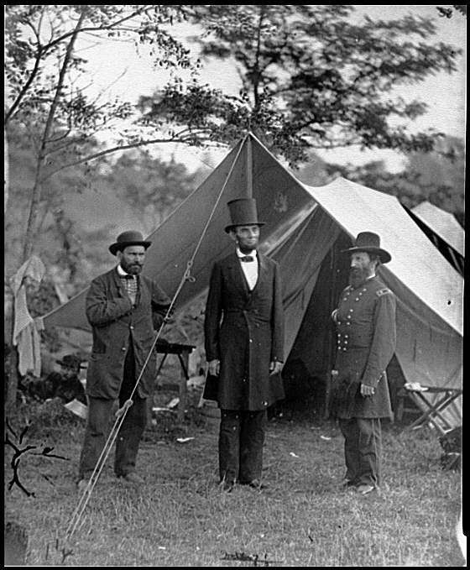 | 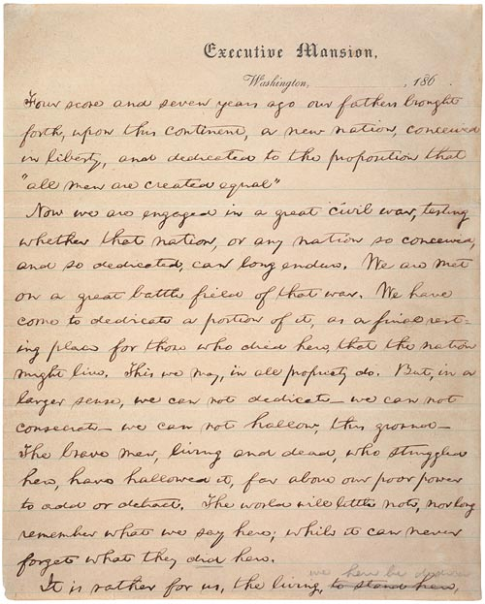 | 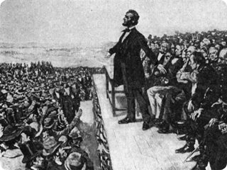

The Gettysburg Address

Four score and seven years ago our fathers brought forth on this continent, a new nation, conceived in Liberty, and dedicated to the proposition that all men are created equal.

Now we are engaged in a great civil war, testing whether that nation, or any nation so conceived and so dedicated, can long endure. We are met on a great battle-field of that war. We have come to dedicate a portion of that field, as a final resting place for those who here gave their lives that that nation might live. It is altogether fitting and proper that we should do this.

But, in a larger sense, we can not dedicate -- we can not consecrate -- we can not hallow -- this ground. The brave men, living and dead, who struggled here, have consecrated it, far above our poor power to add or detract. The world will little note, nor long remember what we say here, but it can never forget what they did here. It is for us the living, rather, to be dedicated here to the unfinished work which they who fought here have thus far so nobly advanced. It is rather for us to be here dedicated to the great task remaining before us -- that from these honored dead we take increased devotion to that cause for which they gave the last full measure of devotion -- that we here highly resolve that these dead shall not have died in vain -- that this nation, under God, shall have a new birth of freedom -- and that government of the people, by the people, for the people, shall not perish from the earth.

Abraham Lincoln
November 19, 1863

Unit 5, Quad 2 Name ________________________________________

The Gettysburg Address

Four score and seven years ago our fathers brought forth on this continent, a new nation, conceived in Liberty, and dedicated to the proposition that all men are created equal.

Now we are engaged in a great civil war, testing whether that nation, or any nation so conceived and so dedicated, can long endure. We are met on a great battle-field of that war. We have come to dedicate a portion of that field, as a final resting place for those who here gave their lives that that nation might live. It is altogether fitting and proper that we should do this.

But, in a larger sense, we can not dedicate -- we can not consecrate -- we can not hallow -- this ground. The brave men, living and dead, who struggled here, have consecrated it, far above our poor power to add or detract. The world will little note, nor long remember what we say here, but it can never forget what they did here. It is for us the living, rather, to be dedicated here to the unfinished work which they who fought here have thus far so nobly advanced. It is rather for us to be here dedicated to the great task remaining before us -- that from these honored dead we take increased devotion to that cause for which they gave the last full measure of devotion -- that we here highly resolve that these dead shall not have died in vain -- that this nation, under God, shall have a new birth of freedom -- and that government of the people, by the people, for the people, shall not perish from the earth.

Abraham Lincoln
November 19, 1863

