Quad #3: Manifest Destiny Name_______________________________________ Due ______________
Analyzing American Progress and U.S. Expansion
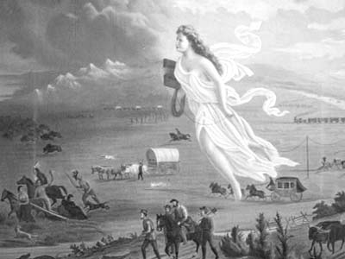 | TITLE American Progress  ARTIST John Gast  PERIOD/PLACE OF IMAGE 19th Century Brooklyn, NY America  MEDIUM Painting: oil  MEASUREMENT 12 ¾” x 16 ¾”  DATE 1872  COUNTRY/SITE USA  LOCATION Museum of the American West, Griffith Park, LA no. 92.126.1 Library of Congress Control no. 975.075.47

1. What is Manifest Destiny? ______________________________________________________________________ ________________________________________________________________________________________________

2. Complete the chart based on the painting (feel free to google a colored copy):
List the people. | List the objects. | List the animals. | List other.
Observations about the people? | Observations about objects? | Observations about animals? | Other observations?

3. What is John Gast’s view of Manifest Destiny (based on his painting, American Progress)? How do you know? (If you need more room to answer this question, continue writing on the back or a separate sheet)

Honors Extension: Carefully read the following excerpt from John L. O’Sullivan’s Manifest Destiny (1839) and answer the questions that follow.

“America is destined for better deeds. We have no interest in the scenes of antiquity, only as lessons of avoidance of nearly all their examples. The expansive future is our arena, and for our history. We are entering on its untrodden space, with the truths of God in our minds, beneficent objects in our hearts, and with a clear conscience unsullied by the past. We are the nation of human progress, and who will, what can, set limits to our onward march? Providence is with us, and no earthly power can. We point to the everlasting truth on the first page of our national declaration, and we proclaim to the millions of other lands, that “the gates of hell” – the powers of aristocracy and monarchy – “shall not prevail against it. Who, then, can doubt that our country is destined to be the great nation of futurity?” (John L. O’Sullivan, Manifest Destiny, 1839)

1. List key words or phrases from the excerpt.

2. Write a definition of “manifest destiny,” based on your list.

3. How does O’Sullivan view the westward expansion of the United States? How do you know?

4. How does O’Sullivan’s quote on “manifest destiny” relate to John Gast’s American Progress?

