Quad #2: Historical comprehension Due:___________________
Create a magazine cover detailing major events and people of the War of 1812. The page can be laid out however you choose but must include all of the following:
-Magazine Title (2 pts)
-A central important image for your “Cover Story”- War of 1812 (5 pts)
-At least 3 news story leads that go along with the cover story (5 points per lead)
-Each lead should have a title, and can include interviews, stories about events, or people. (you do not have to write the actual story.)
-Each lead should be clear and easy to understand how it relates to your topic.
Example covers:
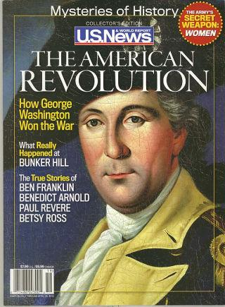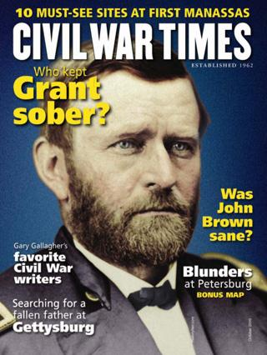

Honors extension: Connect the War of 1812 to the Era of Good Feelings in a written paragraph. Analyze increased nationalism, the changing role in foreign affairs, and the rise of industrialization in the U.S. economy following the war. Additionally, comment on the relationship between war patriotism in today’s society. (8 poins)

