Period 7 Overview: 1890-1945
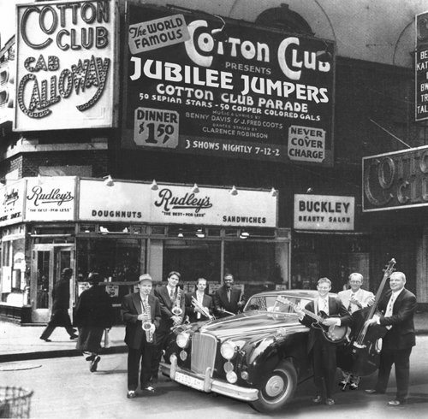
Overview An increasingly pluralistic United States faced profound domestic and global challenges, debated the proper degree of government activism, and sought to define its international role. In less than one lifetime, Americans went from buggies to automobiles to airplanes, as a communications and transportation revolution created a modern consumer culture. Within three decades, the nation experienced two horrific global wars, a colossal economic boom, and the worst depression in the world’s history.

Beginning = End of “Indian Wars”, The Progressive Era – an attempt to fix the problems of the Gilded Age and Populist Movement

What do I need to know?
1. Motives for U.S. expanded overseas (imperialism) and examples
a. Examples: Hawaii, Panama Canal, Spanish/American War, Open Door Policy in China, Roosevelt Corollary
b. Reasons: New Markets post-Depression 1893, Turner’s Thesis, neo­‐ Manifest Destiny, Resources/Raw Materials, Spread Christianity (Civilizing Mission), Military (Alfred Thayer Mahan)
2. How the Progressive Movement attempted to force the FEDERAL government to improve society and fix the problems of the Gilded Age
a. Examples:
i. Economic: Trust Busting, Sherman Antitrust Act, Hepburn Act, Clayton Antitrust Act (Wilson), Federal Reserve Act, The Jungle, Socialism’s rise and fall, Gold Standard
ii. Social: Temperance Movement, Women’s Suffrage Movement, Settlement Homes, Tenement Reform, Child Labor Reforms
iii. Political: Rise of democracy (Wisconsin Idea, LaFollete, 17th Amendment [direct election of senators], Referendum, Recall elections, 19th Amendment [women’s suffrage]
3. Reasons why the U.S. moved from neutrality to intervention in World War I and how the U.S. (under Woodrow Wilson) played a leading role in the peace process
a. Examples: Neutrality To War – “A boat, a note, and a Revolution” Sinking of the Lusitania (boat), Note (Zimmermann Note), Revolution (Russian Revolution), Wilson “Make the World Safe for Democracy”
b. WWI Homefront:
i. Economic: Government purchased wheat and food, industry flourished
ii. Social: Great Migration (African Americans flee Jim Crow South for jobs in northern cities, Anti­‐Immigrant (especially German) treatment, WEB DuBois “Returning Soldiers”
iii. Political: Espionage & Sedition Acts, 19th Amendment,
Restructuring of Gov’t (CPI, War Labor Board, etc.)
c. Post War: Woodrow Wilson “14­‐Points” Speech, League of Nations rejected by US Senate (return to isolationism)
4. How the “Roaring Twenties” represented a time of prosperity
in American cities, but also a time of increased cultural tension
a. Tensions: Sacco & Vanzetti, Red Scare, Wall St. Bombing, Palmer Raids, Quota Act, Scopes Monkey Trial, Racism, Nativism, Prohibition
b. Prosperity: Growth of auto industry, homeownership, radio,
sports
5. How the “New Deal” attempted to solve the problems of the
Great Depression AND forever changed the role of the federal
government by stressing 3 R’s: RELIEF, RECOVERY, and REFORM
a. Examples: Bank Holiday/FDIC, Social Security, Agricultural Adjustment Administration (fix depression on the farm [dust bowl], NERA/NRA [beginning of federal relief [welfare], Wagner Act [minimum wage], TVA/CCC/WPA (public works)
b. Challenges to New Deal and FDR:
i. From the Left: Huey Long “Share the Wealth” Clubs, Father Charles Coughlin (wanted social justice programs)
ii. Supreme Court: Ruled New Deal programs unconstitutional, (NRA, AAA, etc.), Court Packing Scheme (The switch in time that saved nine)
6. Reasons why the U.S. moved from neutrality in World War II to
war after Pearl Harbor
a. Examples: Pacifism, Neutrality Acts, Cash & Carry, Lend­‐Lease
7. How World War II impacted life on the homefront
a. Ends Great Depression
i. Examples: wartime production, women/Mexican/African American labor force
b. Social:
i. Mexican Americans: Bracero Program “Zoot Suit Riots” in LA ii. Japanese Americans: Relocation, Internment Camps, Executive
Order, “Farewell to Manzanar”, Reparations under George HW Bush, Korematsu vs. US
iii. African Americans: “Double V Campaign” (Victory over fascism overseas, racism at home), Congress on Racial Equality (CORE), A Philip Randolph threatened March on Washington for jobs
iv. Women: leverage industrial labor (Rosie the Riveter) into meaningful, if limited, political and economic gains
8. Why the Allies won World War II
a. Examples: War production (Ford Willow Run plant, LA Ship works, etc.), technological innovations (Atomic Bomb/Manhattan Project)
End = World War II Victory! VE/VJ Days

Period Perspectives The era was shaped by continued industrialization, urbanization, and immigration. The role and size of government, especially on the federal level, expanded to meet the challenges of a boom and bust economy and two global wars. Debates over the role of government, science and religion, culture and ethnic diversity also created anxiety and conflicts during this period that included the rebirth of the Ku Klux Klan. In foreign policy, the road from non-intervention to international leadership was unsure, reversed, and then reluctantly accepted by Americans.
Alternate View This period begins with the Spanish-American War in 1898 and ends with World War II in 1945. But politically, the Progressive Era had its roots in the last two decades of the 19th century, and the New Deal coalition built in the 1930s continues to shape politics today.

