Period 4 Overview: 1800-1848
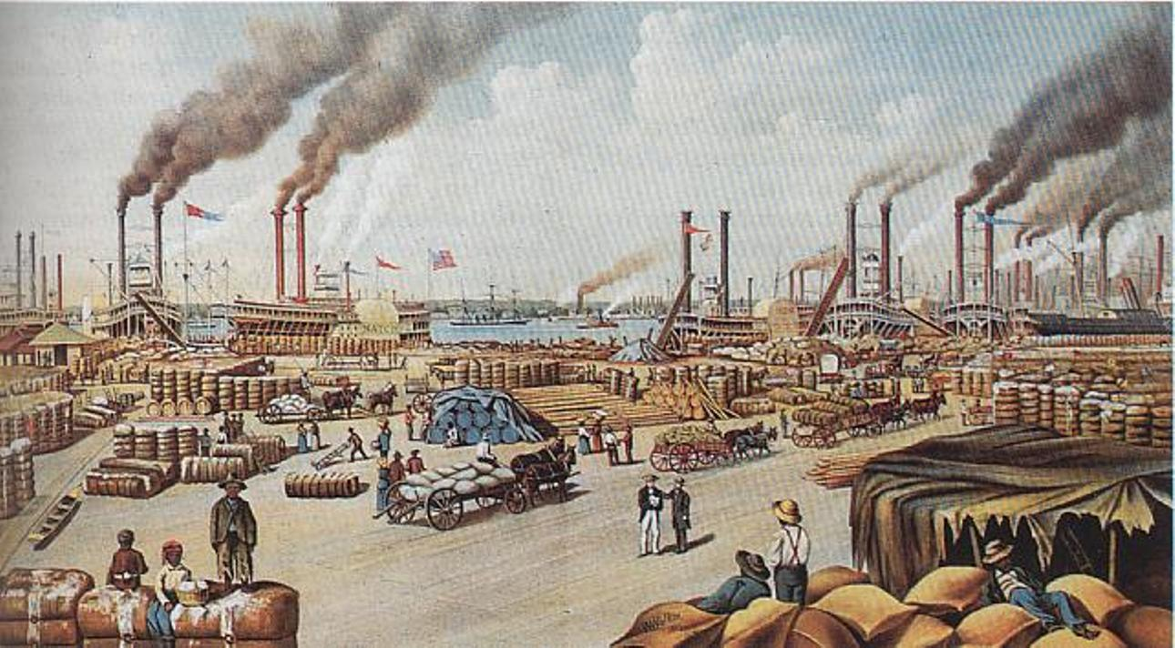
Overview After the peaceful transfer of political power following the 1800 election, the new republic struggled to define and extend democratic ideals in the face of rapid economic, territorial, and demographic changes. In 1826, in the midst of the years covered in this period, the young nation celebrated its 50th birthday with great optimism. The founders of the country were passing on and leadership had passed to a new generation. The United States developed the world’s first modern mass democracy, a new national culture, and a growing market economy. However, sectional interests began to clash, as slavery, wealth disparities, reform efforts, and foreign relations issues threatened to challenge the nation’s ideals moving into the Antebellum Era.

Beginning = Election of Thomas Jefferson (Rise of the Republicans) in 1800. Peaceful transition of power from Federalists to Republicans.

What do I need to know?

1. Why REGIONAL IDENTITIES arose between North, South, and West and how the MARKET REVOLUTION affected each region.
a. Examples: Eli Whitney Cotton Gin, Transportation Revolution (Steamboats, National Road, etc.), immigration and nativism, early factory system, support/opposition to slavery
2. How American society became more DEMOCRATIC (for white men) in the Jacksonian Age and how various social movements attempted to improve society.
a. Examples: Second Great Awakening, Abolitionist Movement, Temperance, Seneca Falls Conference, Public Education, Jackson’s actions as president (Indian Removal, Death of B.U.S., etc.)
3. Reasons for Growth of POLITICAL PARTIES

a. Examples: First Party System (Republicans and Federalists) changes to Second Party System (Democrats and Whigs), Loose vs Strict interpretation of Constitution, Anti­‐Jacksonians become Whigs, various third parties arose

4. The rise of the SLAVERY issue, and how slavery divided the country economically, socially, and politically beginning of SECTIONALISM
a. Examples: American System, Tariff of Abominations, B.U.S., Missouri Compromise, Gag Rule
5. How States challenged FEDERAL authority, supremacy of federal government over the states
a. Examples: Hartford Convention, Nullification Crisis, Marshall Supreme Court, Nullification, Force Act
6. America as a world power…or at least trying to be. =)

a. Examples: Barbary Wars, War of 1812, Monroe Doctrine

End = Mexican/American War and Treaty of Guadalupe…HIDALGO! 1848! Beginning of Sectionalism

Period Perspectives The new republic worked to define itself during a time of rapid demographic, economic, and territorial growth. It increased suffrage; reformed its schools, prisons, and asylums; and developed its own art, literature, and philosophy. These changes took place as a market economy emerged and people benefited from the addition of fertile land farther west and advances in industry and transportation everywhere. The country focused on expanding its borders and trade while avoiding European entanglements.
Alternate View While this period saw growth, the United States also experienced increased conflict with American Indians and its neighbors. Many of the immigrants attracted by new opportunities also found prejudice and discrimination. Rights for the common man excluded American Indians, African Americans, and women. Efforts to improve life succeeded for many but not those enslaved. Landmarks in the institution of slavery came earlier, with the development of the cotton gin in 1793 and the end of the importation of enslaved Africans in 1808. Others came later, such as the Compromise of 1850.

