(Unit 7) Period 8 Timeline of Major Events (1945-1980)
President: | Event and Significance:
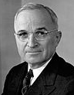  Harry S. Truman  Democrat  (1945-1953) | Servicemen’s Readjustment Act or GI Bill (1944)
 | Formation of the United Nations (1945)
 | Baby Boom (1946-1964)
 | Iron Curtain (1946)
 | Employment Act of 1946
 | Committee on Civil Rights (1946)
 | Levitttown (1947)
 | Taft-Hartley Act (1947)
National Security Act (1947)

- Department of Defense

- National Security Council (NSC)

- Central Intelligence Agency (CIA)

- Selective Service System (1948)

 | Truman Doctrine (1947)
 | Jackie Robinson (1947)
Loyalty Review Board (1947)

- McCarran Internal Security Act (1950)

- Dennis et al v. United States (1951)

- HUAC

  - Hiss Case (1948-50)

  - Rosenberg Case (1951-53)

 | Executive Order 9981 (1948)
Marshall Plan (1948)

- Molotov Plan (1947)

 | Berlin Airlift (1948-49)
 | Truman’s Fair Deal (1949)
 | Sino-Soviet Pact (1950)
 | McCarthyism (1950s)
Korean War (1950-1953)

- June 25, 1950

- Counterattack

- Truman v. MacArthur

- Armistice

 | 22nd Amendment (1951)
 | U.S.-Japanese Security Treaties (1951)
 | Hydrogen Bomb (1952)
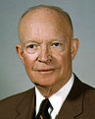  Dwight D. Eisenhower  Republican  (1953-1961) | Department of Health, Education and Welfare (HEW) (1953)
 | Operation Wetback (1954)
 | Geneva Conference (1954)
 | Domino Theory (1954)
 | SEATO South-east Asia Treaty Organization (1954)
 | Brown v. Board of Education of Topeka (1954)
 | Montgomery Bus Boycott (1955)
 | Little Rock Nine (1956)
 | Suez Crisis (1956)
 | Highway Act (1956)
 | Civil Rights Act of 1957
 | Formation of SCLC Southern Christian Leadership Conference (1957)
 | Eisenhower Doctrine (1957)
 | Sputnik (1957)
 | NDEA-National Defense and Education Act (1958)
 | NASA-National Aeronautics and Space Administration (1958)
 | Civil Rights Act of 1960
 | Formation of SNCC, The Student Nonviolent Coordinating Committee (1960)
 | OPEC Organization of Petroleum Exporting Countries (1960)
 | U-2 Incident (1960)
 | “Military-Industrial Complex” (1961)
 | “Beatniks” (1950s-1960s)
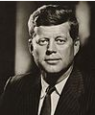

John. F. Kennedy
Democrat
(1961-1963)
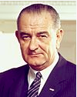

Lyndon B. Johnson
Democrat
(1963-1969)

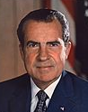

Richard Nixon
Republican
(1969-1974)

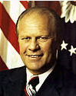

Gerald Ford
Republican
(1974-1977)
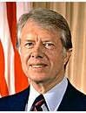

Jimmy Carter
Democrat
(1977-1981)

