Period 2 Overview: 1607-1754
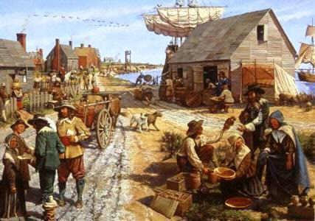
Overview Beginning in 1607, England, France, and Spain all established settlements in North America. Differences in imperial goals, cultures, and North American environments led these nations to develop diverse patterns of colonization. The growth of slavery, triangular trade, Enlightenment ideals and Protestant evangelism helped shape English colonial society and the economy. The French and the Spanish traded and intermarried with Native Americans, and attempted religious conversions. As a result of these differences and growing conflicts between Europeans and Native Americans, distinctive colonial and native societies emerged, leading to a struggle to control resources and the beginning of the Seven Years War.

BEGINNING = Founding of Jamestown settlement in Virginia, 1607.

What do I need to know?

1. Success and Failures of European colonization, (interaction between Natives and European colonists, Europeans and Africans, Work Systems, etc.)
a. Examples: Pueblo Revolt, King Phillip’s War, Slave Trade, Middle Passage, Stono Rebellion, Bacon’s Rebellion
2. How did England become the dominant colonial power? What were the regional DIFFERENCES among English colonies!?
a. Examples: New England Puritans, City Upon A Hill, , Middle Colonies Merchant class, Quakers, Chesapeake Tobacco, Southern Colonies, Cash Crops, slavery
3. Effects of major social movements Enlightenment and Great Awakening on colonial American identity
a. Examples: John Locke “Natural Rights”, Benjamin Franklin, Jonathan Edwards “Sinners in the Hands of an Angry God”, George Whitefield, Reason

END = Start of the French & Indian War 1754 between England and France for control of the Americas and the Ohio River Valley (George Washington starts it)

Period Perspectives From the establishment of the first permanent English settlement in North America to the start of a decisive war for European control of the continent, the colonies evolved. At first, they struggled for survival, but they became a society of permanent farms, plantations, towns, and cities. European settlers brought various cultures, economic plans, and ideas for governing to the Americas. In particular, they all sought to dominate the Native Americans. The British took pride in their tradition of free farmers working the land. The various colonies developed regional or sectional differences based on many influences including geography, climate, natural resources, economic motivations, and religious backgrounds of their settlers. They largely viewed the American Indian as an obstacle to colonial growth. With their emphasis on agriculture came a demand for labor, and this led to a growing dependence on slavery and the Atlantic slave trade to power the economy. The start of the Seven Years' War signified the maturity of the British colonies and the influence of European conflicts in the power struggle for control in North America.
Alternate View Historians disagree on what date best marks the end of the colonial era. Some identify the conclusion of the Seven Years' War in 1763 or the start of the American Revolution in 1775 or the signing of a peace treaty in 1783. Historians who focus on cultural rather than political and military events might choose other dates for both the start and end of the period that emphasize the role of non-English residents, such as the Scotch-Irish, Germans, and enslaved Africans, in the colonies.

