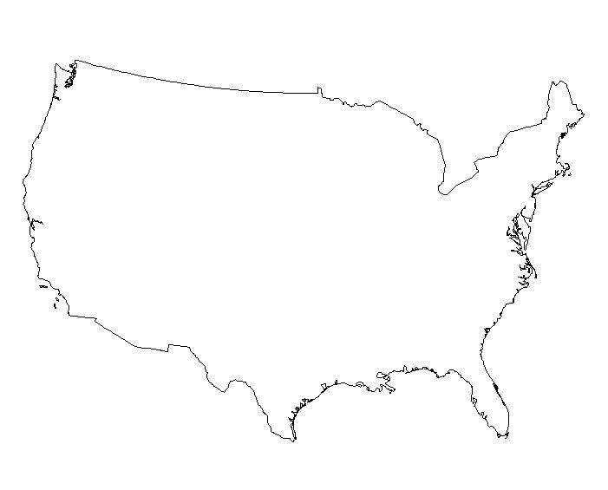
El Paso Council Bluffs

Salt Lake City Los Angeles

Nauvoo Fort Hall

Fort Smith Portland

Santa Fe Alamo*

Sacramento San Jacinto*
Locate, dot, and label
Oregon Trail Old Spanish Trail

Mormon Trail Butterfield Overland Trail

Santa Fe Trail

California Trail

Use different colors to draw in the following trails (put the color below as well).
Original 13 colonies

Treaty of Paris (1783)

Webster-Ashburton Treaty (1842)

Ceded by Britain (1818)

Florida: Adams-Onís Treaty (1819)

Louisiana Purchase (1803)

Republic of Texas and Annexation of Texas

Mexican Cession (1848)

Oregon Territory (1846)

Gadsden Purchase (1853)

Draw in, label, and color the following:
Manifest Destiny Map

“And that claim [US entitlement to the Oregon Territory] is by the right of our manifest destiny to overspread and to possess the whole of the continent which Providence has given us for the development of the great experiment of liberty and federated self-government entrusted to us.”
--John O’ Sullivan, 1845

Territory | Year Acquired | Previous Owner | Circumstances of Acquisition
Original United States | 1783
Louisiana Purchase | 1803
British Cession | 1818
Florida | 1819
Texas | 1845
Oregon Country | 1846
Mexican Cession | 1848
Gadsden Purchase | 1853

