American History I Unit 1b
French and Indian War

Background: England and France
Why are they rivals? |  |  |  | Wars: |  |  | What This Means For Their Colonies:
Disputes Between English and French in North America:
Why is there an issue?

What area does the dispute center around?

French relationship with Natives:

British Colonial Relationship with Natives in Backcountry:

Native concerns:

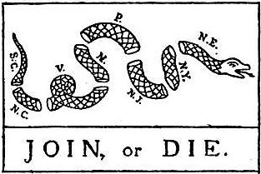
Albany Congress
Date:  Location: | Purpose: |  | Albany Plan of Union  Proposed by:  What did it say/do? |  |  | Outcome?  Reason? |  | Long-Term Impact:
Turning Point
Year? |  | Who? |  | Where? | Why? |  | Outcome? |  | Big Picture Importance

French and Indian War
Sides: Years:

North American Arm of What War?
Early Years: How Was England Doing? |  | How did American Colonists Feel About the War?
What turned the tide of the war? Why were the English able to Start Winning the War?

The War Officially Ends With: | France Loses: | England Gains: | Outcomes for the Spanish:
Mapping European Imperial Colonies in North America
North America in 1750 North America in 1763
Impacts of the French and Indian War
Ways the F&I War Changed the Relationship between England and American Colonists
Colonists were excited about:

Colonists Learned:

War Debt:

What did England expect?

As a result:

Other Problems in the British/American Relationship
British Army: | Pontiac’s Rebellion  When:  Where:  What:  Outcome/Impact: | Proclamation Line of 1763  Created in Response to:  What did it do?  How did Colonists Feel About it and why?

End of Salutary Neglect
F&I War Brought and End to the Policy of : | English Officials Assumed Parliament must: | BIG PICTURE RESULT!!
Why did the new laws and taxes make colonists angry?

How did the colonists respond?

This shift in the relationship is important because:

