American History I Unit 1
Guided Notes: Mercantilism, Trade, and Navigation

Essential Question: (At the end of the lesson, you should be able to answer the following)
- What was the trade relationship between the Old and New Worlds? Who benefitted from that relationship?

Major Components of the Triangular Trade (What does each location provide?)
North and South America | Europe | Africa
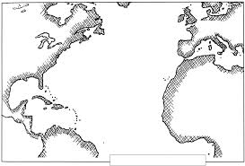

Draw the route of the triangular trade on the map

Define Mercantilism: _______________________________________________________________________________

_______________________________________________________________________________

What does it mean to have a favorable balance of trade?___________________________________________________

The Navigation Acts
What did they say/do?

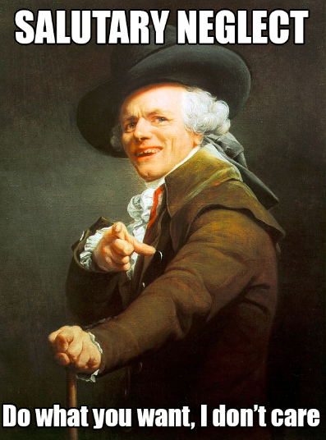
Salutary = _________________ Neglect= _____________________-

What does “Salutary Neglect” mean in American history?

_____________________________________________________________________

_____________________________________________________________________

_____________________________________________________________________

What do you think this will mean for the future?

