American History I Unit 3
The Adams Administration
Election of 1800:
- Federalist Candidate: _____________________ Democratic Republican Candidate ________________________
- Winner: _____________________________
- In what ways did the election of 1800 change American politics?
Changes Instituted By Jefferson
How did Jefferson want to change the national government?

Examples of How he Attempted to Achieve this Goal:

What type of country did Jefferson believe America should be?

Adams and the Midnight Judges
“Midnight Judges” | Jefferson’s Reaction to the “Midnight Judges”
What were they?  What did Adams Hope to Achieve? | How did Jefferson feel about these judges?  What did he do?
Marbury V. Madison
Impact/Outcome: (Why is it so important)

How did the rulings of the Marshall Court influence the American government?

Westward Expansion Under Jefferson
Why Was Jefferson Worried About New Orleans and the Mississippi?

What did Jefferson Attempt to Do?

What was the outcome?

The Louisiana Purchase
When? | From Whom?
How much? | Impact?
Issues with Louisiana Purchase:
- ____________________________________________________________________________________________________
  - Jefferson’s Response ___________________________________________________________________________

- ____________________________________________________________________________________________________
  - Jefferson’s Response ___________________________________________________________________________

Lewis and Clark
Who Are They? | What Were They Asked to Do?
Impact?

Jefferson’s Second Term:
Issues With England
What is Impressment?

Why Were the English Doing This?

Jefferson’s Reaction (What did he do?)

Embargo Act of 1807: (What did it do?) __________________________________________________________________________
____________________________________________________________________________________________________________

Impact of the Embargo Act of 1807: _____________________________________________________________________________
____________________________________________________________________________________________________________
____________________________________________________________________________________________________________
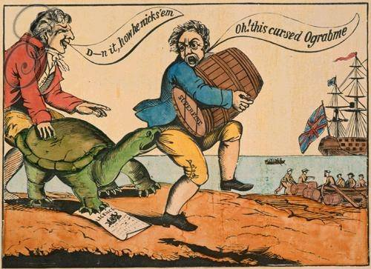
“Ograbme” Cartoon:
Purpose?

