Finding Your Roots, Episode #6 Name _______________________________________ P______D______
EQ: What can we learn about U.S. History from “We Come from People”?
Directions: As we watch the episode, record basic biographical information and the roots/family information about the three prominent African-Americans below.
1.Angela Bassett  Bio: | Roots-  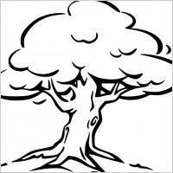 | Family Information-
2.Valerie Jarrett  Bio: | Roots- | Family Information-
3.Nas  Bio: | Roots- | Family Information-

- Why do the three guests profiled know very little about their family histories (beginning of episode)?

- Make a few connections between the people profiled and each other and yourself! (4X Venn)

Angela Bassett

Valerie Jarrett

You

Nas
- Why is this episode entitled, “We Came from People”? Explain.

- In what ways does this episode reflect the period of Reconstruction in U.S. History? Explain the importance of names in your response.

- How did the people profiled in this episode react to the information that was discovered about their families? What do you think explains their reactions?

- Did anything in this episode surprise you? Why or why not?

- Would you be interested in finding your roots? Why or why not?

