WWII Homefront Stations

# Station 1: Life for American Kids

1. **Memories of a Wartime Teenager**  
   *Digital History ID 4144*

Author:   Unknown   
Date:

**Document:** Gasoline was the biggest problem for a teen ager. We still had cars, and gasoline was our biggest worry of all the rationing. We'd always pick up our dates in sequence when we had gas, and you might end up not taking your date home if it would save gas for you to be dropped off first. You'd kiss your date goodnight in front of your house, not hers. Some guys you didn't trust very much, and you wondered if they might not be kissing your girl also, because they would drop their date before yours. You worried about such things, and there were certain guys you didn't double date with because you didn't want them taking your girl home.

Source: Quotation from Archie Satterfield, *The Home Front*, 179

1. **Wartime Childhood in California**  
   *Digital History ID 4139*

Author:   Ann Relph   
Date:

**Annotation:** Anne Relph spent her wartime childhood in California.  
**Document:** To me as a child ... the war never had any reality. It was like a story that someone was telling me ...

We lived in North Hollywood, and they had big searchlights on those hills, I guess to look for aircraft or something. I can remember going up and taking hot coffee to the soldiers in uniform. I was a member of the Civil Air Patrol, which was something they organized for kids. We bought WAC uniforms from the army surplus and were given wooden guns to drill with, and we were taught Morse code and the different kinds of airplanes to watch for. We were never actually used, but we did have a sense of being prepared for something, for some time in the future. That was the only time to me the war seemed real.

Source: Anne Relph, quoted in Roy Hoopes, *Americans Remember the Home Front*, 264.

1. **Memories of a Wartime Girlhood**  
   *Digital History ID 4147*

Author:   Unknown   
Date:

**Annotation:** During the war, girls’ and womens’ stockings, like gasoline, tires, and meat, were rationed.  
**Document:** I was in the eighth grade of a Catholic girls' school at that time and we were taught in no uncertain terms that God was on our side. And the good sisters wouldn't lower their standards for anything. They still insisted that we wear long hose. To show a bare ankle would have caused so much sin in the community that you could even kill each other getting the hose; anything so long as you didn't turn some man on with a bare ankle. So our mothers would go downtown and stand in line so their daughters could have long hose and not go to hell or cause some poor man to go to hell for getting turned on by our bare legs. Isn't that something?

Source: Quoted in Archie Satterfield, *The Home Front*, p. 184.

1. **Wartime Childhood in Mississippi**  
   *Digital History ID 4146*

Author:   Willie Morris   
Date:

**Annotation:** Novelist Willie Morris recalls his wartime childhood in Yazoo City, Mississippi.

**Document:** . . . [T]he teachers would exhort us with shouts and occasional slaps to finish all of our weiners and sauerkraut or our bologna and blackeyed peas. It was our small contribution to the war effort, to eat everything on our plate. Once the third grade teacher, known as the cruelest in the school, stood over me and forced me to eat a plateful of sauerkraut, which I did, gagging and in tears, wishing I could leave . . . and never come back….

The war itself was a glorious and incomparable thing, a great panorama intended purely for the gratification of one's imagination. I kept a diary on all the crucial battles, which I followed every day in the pages of the Memphis Commercial Appeal and the Jackson Daily News, and whenever the Allies won one of them, I would tie tin cans to a string and drag them clattering down the empty sidewalks of Grand Avenue.We never missed the latest war film, and luxuriated in the unrelieved hatred exercised for the Germans and the japs. How we hated the japs, those grinning creatures who pried off fingernails, sawed off eyelashes with razors, and bayoneted babies! The Germans we also hated, but slightly less so, because they looked more like us ....

Source: Willie Morris, *North Toward Home*, 20, 35.

# Station 2: Internment

**Growth of Japanese Immigration**

President Franklin Roosevelt called it “a date which will live in infamy.” Early Sunday morning, December 7, 1941, Japanese bombs fell on Pearl Harbor, the U.S. naval base in Hawaii. It was a scene of nearly total destruction. Two thousand Americans were killed and an equal number wounded. America’s offensive naval power in the Pacific had been wiped out. The surprise attack meant war between the Empire of Japan and the United States.

The attack on Pearl Harbor was a tremendous shock to all Americans. Its aftermath was especially dreaded by Americans of Japanese ancestry. They feared that in the panic following the attack, hostility toward them might grow. They might be linked to the Japanese enemy abroad. There was good reason for them to feel alarmed. Prejudice against Japanese- Americans had been widespread, especially on the West Coast, for one half-century before Pearl Harbor.

Soon after Commodore Matthew Perry opened contact with Japan in 1854, some Japanese were issued passports for travel to the United States. Immigration for Japan to the United States remained a trickle until 1891. In that year the number of Japanese entering the United States reached 1,000 for the first time. The new immigrants were largely young, poor, single men. Many came expecting to return to Japan once they earned enough money to buy land there. Unable to save the necessary amount, some became permanent residents in the United States. The 1920 census reported 110,010 Japanese in the U.S. mainland. The young Japanese males who settled in the United States were prevented by law and custom from marrying white women. Instead many took “picture brides.” Often on the basis of only a photograph, their marriages were arranged by matchmakers in Japan. The young brides-to-be sailed to meet their perspective husbands, sight unseen.

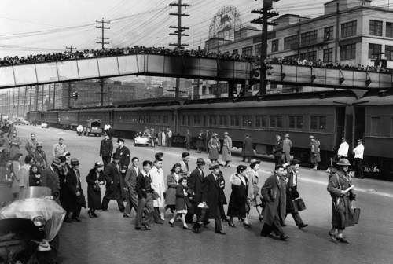

The ***Issei***, first generation Japanese-Americans immigrants, settled mostly in California, Oregon, and Washington. The majority worked in fruit orchards, vineyards, and farms. Others found jobs laboring for the railroads, in canneries, logging, and meat-packing. At first the Issei were welcomed by the local residents. There was a high demand for their labor. Industrious and willing to work for low wages, they did not complain about their working conditions. The ambitious Issei soon became unpopular. Unions regarded them as unwelcome competitors for jobs. Local farmers often resented the Issei success of growing citrus fruits, potatoes, and rice. The value of Issei farm crops grew from $6 million in 1909

to $67 million just ten years later.

J**apanese-Americans Reporting for Relocation**

**Anti-Japanese Sentiment**

Anti-Japanese feeling grew along the West Coast. Some of it stemmed from racial prejudice. Many white Americans would not accept nonwhites as equals. Some California newspapers began writing about a *yellow peril*. This notion suggested that waves of Japanese immigrants would gradually engulf the state. The immigrants were portrayed as tricky, deceitful, and treacherous. Official actions were taken against the Japanese. In 1906 the San Francisco school board established separate schools for Japanese children. Pressure exerted on President Theodore Roosevelt to stop Japanese immigration led to the **“Gentleman’s Agreement”** with Japan in 1907. As part of the agreement the Japanese government agreed to reduce immigration to the United States. In exchange, the United States promised not to adopt laws that discriminated against the Japanese. In 1907 30,824 Japanese entered the United States. The year following the agreement, immigration from Japan dropped to 3,275.

In 1922, the U.S. Supreme Court declared that Japanese immigrants (Issei) were “aliens ineligible to citizenship.” The basis for this denial was a 1790 act of Congress that limited citizenship to “free white persons.” After the Civil War the law was expanded to include persons of African descent. The effect of the Supreme Court decision was that white immigrants from Europe and blacks from Africa could become naturalized U.S. citizens, but Asians could not. The children of the Issei, called ***Nisei*,** were, however, legally U.S. citizens. According to the Constitution anyone born in the United States is a citizen. The goal of halting Japanese immigration to the United States was accomplished in 1924. That year, while admitting immigrants from other parts of the world, Congress excluded all immigration from Asiatic countries. The action infuriated the Japanese government, which claimed the United States had violated the Gentleman’s Agreement.

There were other ways, though not enforced by law, that Americans of Japanese origin were branded with a badge of inferiority. For example, they were often refused housing in white neighborhoods. A California billboard of the period read: “Japs, don’t let the sun shine on you here. Keep moving.”

**Growing Public Fear after Pearl Harbor**

It is no wonder that the Issei and their Nisei children dreaded what might be done to them after Pearl Harbor. In the aftermath of the sneak attack, well-publicized remarks by some prominent Americans stirred the panic. For example, a columnist for the *San Francisco Examiner* said:

*Everywhere the Japanese have attacked to date, the Japanese population has risen to aid the attackers…. I am for the immediate removal of every Japanese person on the West Coast to a point deep in the interior. Herd ‘em up, pack ‘em off and give ‘em the inside room in the Badlands. Let ‘em be pinched, hurt, hungry, and dead up against it.*

U.S. Army General John DeWitt, military commander of the newly created Western Defense Command, envisioned immediate dangers on the West Coast. He expected naval attacks and air raids. Adding to the danger, the general believed, was the likelihood that Japanese living along the West Coast would commit acts of *sabotage* (destruction of property by enemy agents) and *espionage* (spying to obtain government secrets). In a report to the secretary of war, General DeWitt said:

*In the war in which we are now engaged, racial affinities are not severed by migration. The Japanese race is an enemy race and while many second and third generation Japanese born on United States soil, possessed of United States citizenship, have become “Americanized,” the racial strains are undiluted…. It therefore follows that along the vital Pacific Coast over 112,000 potential enemies of Japanese extraction are alive today.*

In January 1942, Earl Warren, then attorney general of California, declared that Japanese-Americans had “infiltrated… every strategic spot” in California. He added, “I have come to the conclusion that the Japanese situation as it exists in this state today, may well be the ‘Achilles heel’ (weakness) of the entire civilian defense effort. Unless something is done it may bring about a repetition of Pearl Harbor.” The remark that most fueled public hostility was a widely reported one made by Secretary of the Navy, Frank Knox. After inspecting the extensive damage at Pear Harbor, he held a press conference in Los Angeles. There he said that the Japanese attack had been accompanied by “the most effective fifth column work that’s come out of this war.” The term *fifth column* refers to any secret organization within a country that aids an invading enemy.

Rumors circulated about Japanese-Americans pointing the way for Japanese pilots at Pearl Harbor or aiding the enemy in other ways. These rumors were false. Not a single act of sabotage or espionage by a Japanese-American in Hawaii was ever proven. Nonetheless, the scare stories were widely believed. Contributing to public anxiety during early months of the war was grim news from the South Pacific. Japanese military forces were making swift progress there. Allied defeats at Manila, Guam, Wake Island, and Hong Kong weighed heavily on the hearts of Americans. By February 1942, the military position of the US in the Pacific was perilous. It was a time of fear.

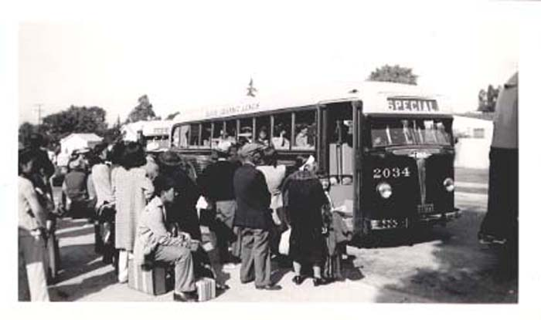The war was moving closer to home. Japanese submarines attacked shipping near the California coast. There were reports of signaling from the Pacific Coast to enemy ships at sea, both by radio and by flashing lights. Residents of the coastal states expected a Japanese attack.

**Executive Order 9066**

A growing sentiment for the evacuation of Japanese-Americans resulted in government action. In February 1942 President Roosevelt issued **Executive Order 9066**. It gave the army authority to move civilians out of the Pacific coastal states. In March, Congress unanimously passed **Public Law 503**, which provided for enforcement of the president’s order in the courts. Under the authority of the new law, the army began issuing civilian evacuations orders. Within a week after orders were posted in an area, all Japanese, whether citizens or not, were required to prepare to evacuate.

**Evacuation of Japanese Americans**

One member of each family was required to report for registration. Within five days of registration all Japanese in an area were processed for removal. On the day of departure they were given identification tags and transported by bus or train to temporary assembly centers along the West Coast. They were to remain there until permanent inland relocation centers were ready for them. Over 120,000 Japanese, two-thirds of them U.S. citizens, were evacuated. Although the United States was at war with Germany and Italy, no German-Americans or Italian-Americans were evicted from their homes.

**Justification for Relocation**

The federal government argued that mass evacuation was a military necessity. Several reasons were given to support this argument. Some of the major ones were:

1. The Japanese-Americans posed a threat as enemy agents. Many of them lived around aircraft plants, ports, dams, bridges, power stations, and other strategic points.
2. Widespread distrust of the Japanese lowered public morale on the West Coast. Evacuation would lift morale.
3. The Japanese themselves were in danger of attack by angry citizens. There had been several violent acts, including murders, committed against them. In relocation camps they would be safe.
4. Loyalty of the Japanese-Americans to the United States was doubtful. There was no way to distinguish loyal U.S. citizens from those whose first loyalty was to Japan. All Americans of Japanese ancestry were considered citizens of Japan by the Japanese government. Some had sent their children to Japan to schooling. As a group, the Japanese in the United States had maintained their cultural traditions and had not blended into the mainstream of American life.
5. In total war, constitutional rights have to give way to drastic measures.

**Relocation**

Yoshiko Uchida, in her book *Desert Exile*, describes what it was like for her family to be uprooted from their home in 1942. At the time of the evacuation, the Uchida family consisted of Yoshiko, a college student, her older sister, Keiko, and their parents. The girls were both Nisei. Their Issei parents had a strong devotion to their adopted country. The family lived comfortably in a house in Berkeley, California. On national holidays Mr. Uchida hung an enormous American flag on the front porch.

At five o’clock on Pearl Harbor Day, Yoshiko came home from the library to find an FBI agent in the living room. Her father was gone. As an executive of a Japanese business firm, he was one of many *aliens* (non-citizen residents) considered especially dangerous by the government. They were seized immediately after the Japanese attack and sent to an internment camp in Montana.

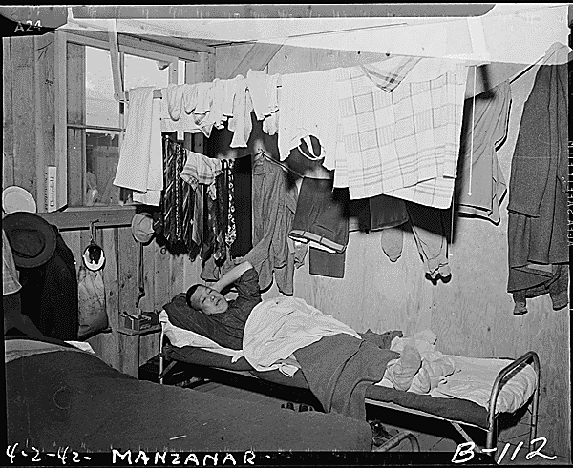

In April 1942, Yoshiko, her mother and her sister were ordered to report to Tanforen Assembly Center. They had ten days to prepare. They desperately tried to dispose of their household possessions. The piano was left with one neighbor; other pieces of furniture with another. Like many others, they suffered financial losses in having to dispose of their property so quickly. Other had to abandon their businesses or sell them at a loss.

On the day of departure the three women arrived at their church, the designated assembly point, carrying the few belongings they were permitted to bring. They were taken to a fenced-in camp far removed from the West Coast. It had rained the day before their arrival. The grounds had become a mass of slippery mud. The girls helped their mother through the mud past tar-papered barracks until they reached Barrack 16, the one to which they had been assigned. It was a horse stable. Each stall was about ten feet by twenty feet, empty except for three folded army cots. The smell of horses stung the air.

**Barracks in a Relocation Center**

The family stall was cold and dank and afforded little privacy. Meals were served in a mess hall. Their first dinner at Tanforen consisted of two canned sausages, a boiled potato, and a piece of plain bread. Meals improved, but most of the time they were skimpy and starchy. Yoshiko and her sister were usually hungry.

Gradually the interned residents worked to improve conditions at Tanforen, a community of 8,000. A form of limited self-government was set up. Buddhist and Christian churches were established. A post office was opened. Education and recreation programs were organized. Yoshiko worked in the elementary school, for which she was paid $16 dollars a month. Eventually, her father was allowed to join the family in their stall at the temporary assembly center.

After five months at Tanforen the family was sent to Topaz, a relocation center in the Utah desert. They found a crude, incomplete, and ill-prepared camp. Yoshiko and her family felt depressed in the bleak desert camp. Military police patrolled the barbed wire perimeter of the camp. Swirling masses of sand in the air constantly coated their bodies and clothing. There were few comforts, and life at Topaz was only slightly better than it had been at Tanforen.

The Uchida family adjusted to the routine hardships of camp life, but they missed their house in Berkeley. Yoshoko, homesick, angry, and despairing, characterized her life at Topaz: “No matter what I did, I was still in an artificial government-sponsored community on the periphery of the real world. I was in a dismal, dreary camp surrounded by barbed wire in the middle of a stark, harsh landscape that offered nothing to refresh the eye or heal the spirit.”

Some Japanese-Americans spent three years in one of ten government relocation centers like Topaz. The Uchida family spent just over a year in confinement. Upon their release they gradually returned to a comfortable life as Americans. The bitterness of their bondage lingered in their memories after the war.

The vast majority of Japanese-Americans, like the Uchida family, cooperated fully with government authorities during the relocation period. A dramatic demonstration of patriotism came from the men of the 442nd Regimental Combat Team. After Pearl Harbor, Americans of Japanese decent were excluded from the armed forces of the United States. In 1943 the government allowed Japanese-Americans to volunteer for the army. An all-Nisei combat team was established. The unit fought in Europe with extraordinary bravery. It was one of the most highly decorated U.S. combat units of the war. It suffered over 9,000 casualties, including 600 dead.

Not all Japanese-Americans declared loyalty to the U.S. government. At Tule Lake, one of the relocation centers, a militant minority was openly pro-Japan during the war. More than 5,000 members of this minority renounced their U.S. citizenship. Also, at the end of the war, 4,724 residents of relocation centers chose to return to Japan.

***Korematsu v. United States***

A small number of Japanese-American resisted the evacuation when it began. One of them, born and raised in the United States, was Fred Korematsu. After graduation from high school in Oakland, California, Fred worked in a shipyard as a welder. At the outbreak of the war his membership in the Boilermaker’s Union was cancelled because of his race. He took a job as a gardener and fell in love with a white woman.

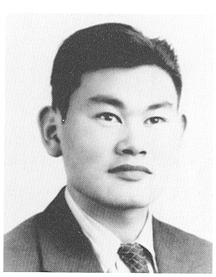The evacuation orders disrupted the couple’s plan to marry. In an effort to escape detention, Fred had plastic surgery done on his face, changed his name, and posed as a Spanish-Hawaiian. The ruse failed. While leaving a post office near Oakland, he was seized by FBI agents. In federal court Korematsu was found guilty of breaking the law.

Fred Korematsu appealed his conviction to the U.S. Supreme Court. In the case of ***Korematsu v. Unites States*** (1944), the high court was asked to decide whether the evacuation and relocation of Japanese-Americans violated their constitutional rights. The nine justices of the Supreme Court voted 6 to 3 to uphold Korematsu’s conviction. Speaking for the majority Justice Hugo Black said:

*Korematsu was not excluded from the Military Area because of hostility to him or his race. He was excluded because we are at war with the Japanese Empire, because the properly constituted military authorities feared an invasion of our West Coast and felt constrained to take proper security measures, because they decided that the military urgency of the situation demanded that all citizens of Japanese ancestry be segregated from the West Coast temporarily , and finally, because Congress, reposing its confidence in this time of war in our military leaders – as inevitably it must – determined that they should have the power to do this.*

**Fred Korematsu**

The decision in the Korematsu case upheld the constitutionality of excluding Japanese-Americans from the Pacific Coast during the Second World War. But three justices dissented from the majority opinion. Justice Own J. Roberts argued that Korematsu was a loyal citizen of the nation. He added that it was a violation of constitutional rights to imprison a citizen solely because of his ancestry and without evidence of his disloyalty. Justice Frank Murphy added strong words in his dissenting opinion. He wrote that the order to exclude all persons of Japanese ancestry from the Pacific Coast “goes over the very brink of constitutional power and falls into the ugly abyss of racism.” He continued:

*Being an obvious racial discrimination, the order deprives all those within its scope of the equal protection of the laws as guaranteed by the Fifth Amendment. It further deprives these individuals of their constitutional rights to live and work where they will, to establish a home where they choose and to move about freely...*Racial discrimination in any from and in any degree has no Justifiable part whatsoever in our democratic way of life.”

In the third dissenting opinion, Justice Robert H. Jackson agreed that it was unconstitutional to transplant Americans on the basis of their race. He wrote that by declaring the exclusion order constitutional, the Supreme Court was, for all time, accepting the principle of racial discrimination: “The principle then lies about like a loaded weapon ready for the hand of any authority that can bring forward a plausible claim of an urgent need.”

# Station 3: Women

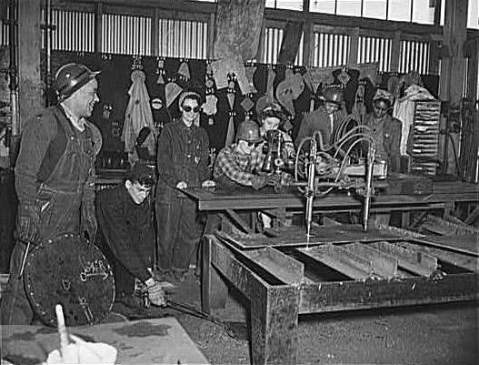

1. **Women Learning To Use A Pantograph And Template For Cutting At The Bethlehem-Fairfield Shipyards. Baltimore, Maryland.** *Digital History ID 2618*

**Credit:** Library of Congress  
**Media type:** photograph  
**Museum Number:** LC-USW3-028672-C  
**Annotation:** The large numbers of women employed in wartime jobs helped them organize and gain momentum to move forward to fight for equal rights and welfare reform after the war.  
**Year:** 1943

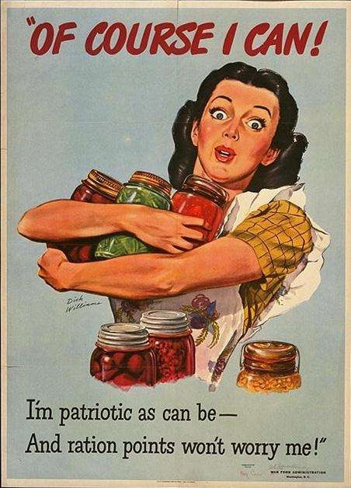

1. **WW II Posters: Of Course I Can!** *Digital History ID 2836*

**Credit:** World War II Poster Collection, Northwestern University Library  
**Media type:** poster  
**Museum Number:**   
**Annotation:** This WWII poster promotes food conservation through home canning.  
**Year:** 1944

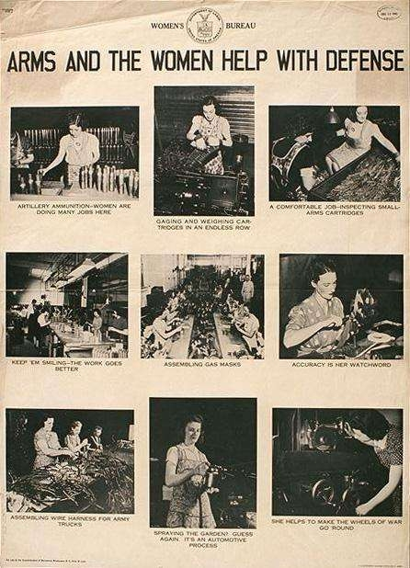

1. **WW II Posters: Arms and the Women Help With Defense** *Digital History ID 2849*

**Credit:** World War II Poster Collection, Northwestern University Library  
**Media type:** poster  
**Museum Number:**   
**Annotation:** Some of the captions under the photos on this poster read: *Artillery ammunition—women are doing many jobs here; Assembling gas masks; Accuracy is her watchword; She helps to make the wheels of war go round.*  
**Year:** 1942

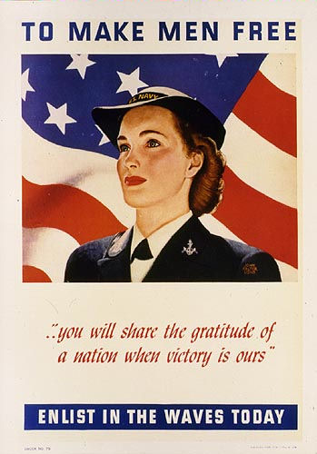

1. **WAVES Enlistment Poster**

The **United States Naval Reserve (Women's Reserve)**, better known under the acronym **WAVES** for **Women Accepted for Volunteer Emergency Service**, was the World War II women's branch of the United States Naval Reserve. It was established on 21 July 1942 by the U.S. Congress and signed into law by the president on 30 July 1942. This authorized the U.S. Navy to accept women into the naval reserve as commissioned officers and at the enlisted level, effective for the duration of the war plus six months. The purpose of the law was to release officers and men for sea duty and replace them with women in shore stations. Mildred H. McAfee became the first director of the WAVES. She was commissioned a lieutenant commander in the Navy on 3 August 1942, and was the first woman commissioned in the U.S. Naval Reserve. (She was later promoted to captain.) McAfee, on leave as president of Wellesley College, was an experienced educator and highly respected in her field.

Wanting to serve their country in time of need was a strong incentive for young women during World War II. And thousands of them saw fit to join the WAVES. With some, it was for adventure, for others it was professional development, and still others joined for the chance to experience life on college campuses. Some followed family traditions and others yearned for a life other than as a civilian.

Ruby Messer Barber had this to say about joining the WAVES, "It was a choice of adventure. I didn't have any brothers, and I thought that's something I can do, one way I can make a contribution. My sisters thought it was great, but they were not interested. There was too much discipline and routine involved. I felt like it would be a challenge, to step forth and do it, to see what it was all about. It gave a sense of confidence. At the time girls just didn't join the WAVES or go into the military. But my Dad, he said, you'll be OK".

Lieutenant Lillian Pimlott wrote to her mother, after being deployed to Pearl Harbor, and said, "I was fascinated by the ships which are making history in every battle. I've talked to seamen and I've met flyers-from Iwo (Iwo Jima), from Okinawa, heroes from every encounter. I know now what war means and my heart goes out to every one of them. Among them I am making, I hope, life long friends, for their experiences mean everything to my self-satisfaction ... As long as they fight on, I have no desire to return home, for I feel I belong here ... I have learned much in these brief three months about life and living. And I know I have already changed in many ways and many viewpoints ... It is truly a most broadening experience and I shall never outlive it"

The WAVES served in 900 shore stations in the continental United States. Initially, they were prohibited from serving in commands afloat and outside the country. But in September 1944, Congress amended the law allowing WAVES to volunteer for service in the territories of Alaska and Hawaii. Hawaii became the only overseas station staffed with WAVES on a permanent basis. By the end of the war, 18% of the naval personnel assigned to shore stations were women. Officers served in many professional capacities, including doctors; attorneys; engineers and mathematicians, and chaplains. One WAVE mathematician was assigned to Harvard University to work on the computation project with the Mark I computer. Another became the only female nautical engineer in the entire U.S. Navy. Enlisted WAVES worked in jobs such as aviation machinist; aviation metalsmith; parachute rigger; control tower operator; radiomen; yeomen (secretary); statistician; administration; personnel, and health care. Although some enlisted women had the opportunity to work in fields previously held by men, most of them actually worked in secretarial and clerical positions.

The WAVES enjoyed many successes in the work place, but they also suffered from intolerance. Some of the problems sprang from contradictory attitudes of men who supervised women. Often, the women were underutilized in relation to their training, with others it was assignments beyond their physical abilities, and in some cases women were utilized only out of dire need. The mission of the WAVES was to replace men in shore stations for sea duty. Still, certain men were hostile to WAVES because being replaced meant sea duty.

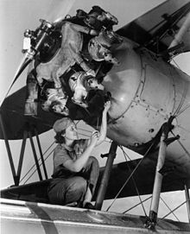

Photo above: Enlisted WAVE Mary Josephine Farley, aviation mechanic

<https://en.wikipedia.org/wiki/WAVES#Women_of_the_WAVES>

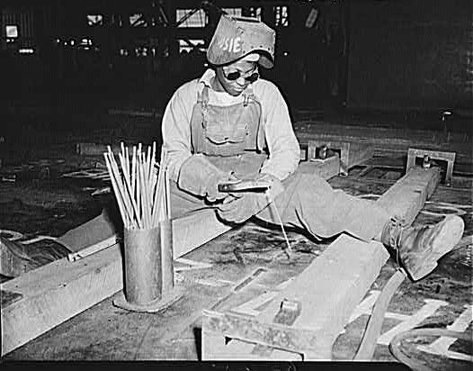

1. **Negro Woman Welder. Bethlehem-Fairfield Shipyards, Baltimore, Maryland.** *Digital History ID 2619*

**Credit:** Library of Congress  
**Media type:** photograph  
**Museum Number:** LC-USW3- 028671-C  
**Annotation:** Women made a huge contribution to World War II. In addition to the women who worked in factories during the war, large numbers of women substituted for men and worked on farms and volunteered with the Red Cross or Women’s organizations such as the USO, while countless others worked in the military.  
**Year:** 1943

# Station 4: Mexican-Americans

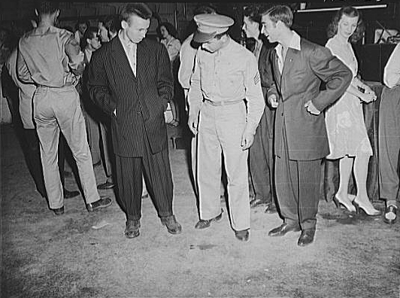

**Washington, D.C. Soldier Inspecting a Couple of Men in Zoot Suits** *Digital History ID 2638*

**Credit:** Library of Congress  
**Media type:** photograph  
**Museum Number:** LC-USF34- 011543-D  
**Annotation:** The Zoot Suit’s rise in popularity was first seen during the Harlem jazz period of the 1930s. During WWII, in an effort to reserve fabric for military uniforms, restrictions were placed on the amount of fabric designated for men and women’s clothing. It was also during this time that Los Angeles hosted a series of Zoot Suit riots, disputes between servicemen and the Hispanic men that wore the recognizable suit.   
**Year:** 1942

**The Zoot Suit Riots**  
*Digital History ID 606*

Author:   Governor's Citizen's Committee Report on Los Angeles Riots   
Date:1943

**Annotation:** At the end of the three-month Sleepy Lagoon trial, a public campaign against Mexican American youth intensified. Over a two-week period in May and June 1943, police stood by while several thousand servicemen and civilizations beat up Mexican American youth, stripping them of their draped jackets and pegged pants. The Los Angeles City Council banned zoot suits within the city. The "zoot-suit riots" have become a symbol of wartime prejudice and ethnic strife.

California's Governor, Earl Warren, formed a committee to investigate the causes of the "Zoot Suit" riots. Excerpts from the report follow.

**Document:** There are approximately 250,000 persons of Mexican descent in Los Angeles County. Living conditions among the majority of these people are far below the general level of the community. Housing is inadequate; sanitation is bad and is made worse by congestion. Recreational facilities for children are very poor; and there is insufficient supervision of the playgrounds, swimming pools and other youth centers. Such conditions are breeding places for juvenile delinquency....

Mass arrests, dragnet raids, and other wholesale classifications of groups of people are based on false premises and tend merely to aggravate the situation. Any American citizen suspected of crime is entitled to be treated as an individual, to be indicted as such, and to be tried, both at law and in the forum of public opinion, on his merits or errors, regardless of race, color, creed, or the kind of clothes he wears.

Group accusations foster race prejudice, the entire group accused want revenge and vindication. The public is led to believe that every person in the accused group is guilty of crime.

It is significant that most of the persons mistreated during the recent incidents in Los Angeles were either persons of Mexican descent or Negroes. In undertaking to deal with the cause of these outbreaks, the existence of race prejudice cannot be ignored....

On Monday evening, June seventh, thousands of Angelenos, in response to twelve hours' advance notice in the press, turned out for a mass lynching. Marching through the streets of downtown Los Angeles, a mob of several thousand soldiers, sailors, and civilians, proceeded to beat up every zoot-suiter they could find. Pushing its way into the important motion picture theaters, the mob ordered the management to turn on the house lights and then ranged up and down the aisles dragging Mexicans out of their seats. Street cars were halted while Mexicans, and some Filipinos and Negroes, were jerked out of their seats, pushed into the streets, and beaten with sadistic frenzy. If the victims wore zoot-suits, they were stripped of their clothing and left naked or half-naked on the streets, bleeding and bruised. Proceeding down Main Street from First to Twelfth, the mob stopped on the edge of the Negro district. Learning that the Negroes planned a warm reception for them, the mobsters turned back and marched through the Mexican cast side spreading panic and terror.

Throughout the night the Mexican communities were in the wildest possible turmoil. Scores of Mexican mothers were trying to locate their youngsters and several hundred Mexicans milled around each of the police substations and the Central Jail trying to get word of missing members of their families. Boys came into the police stations saying: "Charge me with vagrancy or anything, but don't send me out there!" pointing to the streets where other boys, as young as twelve and thirteen years of age, were being beaten and stripped of their clothes... not more than half of the victims were actually wearing zoot-suits. A Negro defense worker, wearing a defense-plant identification badge on his workclothes, was taken from a street car and one of his eyes was gouged out with a knife. Huge half-page photographs, showing Mexican boys stripped of their clothes, cowering on the pavement, often bleeding profusely, surrounded by jeering mobs of men and women, appeared in all the Los Angeles newspapers....

At midnight on June seventh, the military authorities decided that the local police were completely unable or unwilling to handle the situation, despite the fact that a thousand reserve officers had been called up. The entire downtown area of Los Angeles was then declared "out of bounds" for military personnel. This order immediately slowed down the pace of the rioting. The moment the Military Police and Shore Patrol went into action, the rioting quieted down.

Source: *Governor's Citizen's Committee Report on Los Angeles Riots,* 1943.

**Aftermath**

Remarkably, no one was killed during the riots, although many people were injured. The fact that considerably more Mexican Americans than servicemen were arrested—upward of 600 of the former, according to some estimates—fueled criticism of the Los Angeles Police Department’s response to the riots from some quarters.

As the riots died down, California Gov. Earl Warren ordered the creation of a citizens’ committee to investigate and determine the cause of the Zoot Suit Riots. The committee’s report indicated that there were several factors involved but that racism was the central cause of the riots and that it was exacerbated by the response of the Los Angeles Police Department as well as by biased and inflammatory media coverage. Los Angeles Mayor Fletcher Bowron, concerned about the riots’ negative impact on the city’s image, issued his own conclusion, stating that racial prejudice was not a factor and that the riots were caused by juvenile delinquents.

<http://www.britannica.com/event/Zoot-Suit-Riots>

# Station 5: African Americans

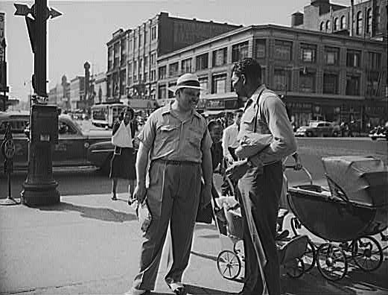

**Street Scene In Harlem** *Digital History ID 2595*

**Credit:** Library of Congress  
**Media type:** photograph  
**Museum Number:** LC-USW3-031113-C  
**Annotation:** Harlem was thriving in the 1940s: bustling with men in uniform and on the scene were great musicians, such as Duke Ellington and Count Basie, authors, such as Zora Neale Hurston, and famous clubs, such as the Cotton Club and the Savoy Ballroom.  
**Year:** 1943

Tuskegee Airmen

The Tuskegee airmen were the first black servicemen to serve as military aviators in the U.S. armed forces, flying with distinction during World War II. Though subject to racial discrimination both at home and abroad, the 996 pilots and more than 15,000 ground personnel who served with the all-black units would be credited with some 15,500 combat sorties and earn over 150 Distinguished Flying Crosses for their achievements. The highly publicized successes of the Tuskegee Airmen helped pave the way for the eventual integration of the U.S. armed forces under President Harry Truman in 1948.

Watch the 3 min video interview: <http://www.history.com/topics/world-war-ii/tuskegee-airmen>

# Station 6: Native-Americans

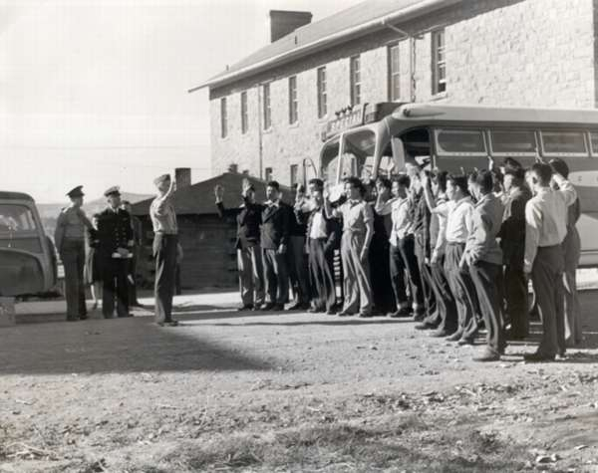

**First 29 Navajo US Marine Corps Code-talker Recruit** *Digital History ID 2773*

**Credit:** National Archives  
**Media type:** photograph  
**Museum Number:**   
**Annotation:** During World War II, a code of communication based on the Navajo’s unwritten, complex native language was devised that remained undecipherable by the enemy. From 1942-1945, over 400 Navajo code talkers were recruited from reservations to participate in the Pacific theater. Their primary job was to transmit tactical information about troop movements and other pertinent information that assisted the U.S. advancement in the war. The Marines relied on the code talkers when they took Iwo Jima.

Watch the 9 minute video on Code Talkers: <https://www.youtube.com/watch?v=GkBASFMYwL0>

The story of the Navajo Code Talkers begins in 1940 when a small group of Chippewas and Oneidas became a part of the radio communications 32nd Infantry Division. Soon after, Sac and Fox tribes joined in the ranks as combat radiomen. The complexity of Navajo linguistics allowed it to become an ideal choice to be used in code due to the lack of documentation made available for learning to speak the language and ability for the same words to mean multiple things based on sound. The legacy of the Navajo Code Talkers will continue as many documentary and stories have been shared about their journey since it’s declassification during Reagan’s Administration.

(originally from <http://navajocodetalkers.org/story-of-the-navajo-code-talkers/>)