1950s Album Cover Art Project – The Hits of the 1950s!
Directions: Justify and explain in at least three (3) sentences the significance of each song and how it relates to the 1950s. You may choose a song from the years of 1950 to 1964 in your project.

You must include the following topics on the BACK of your album cover.
- A Song Involving the Space Race
- A Song Involving Living in the Suburbs (i.e. Family Life—something representative of the 50s family)
- A Song About Life for Women
- A Song Involving the Non-Conformity of the 1950s (can be a criticism of it as well!)
- A Popular Rock ‘n’ Roll Song/Artist
- A Song Involving the New Technology of the 1950s (it could also use new techniques of making music-synthesizers, etc.)
- A Song About Life for a Teenager/Teenage Angst
- A Famous Love Song
- A theme song for a popular movie, TV show, radio show, etc.
- A song involving a famous African-American (Possibly showing origins of the Civil Rights if you can find one!).

Album Example: Front (Top) and Back (Below)
The front cover should have:
- Your band’s name.
- Your album’s title.
- Three Song Titles
- Cover Art
- Your record label’s name.
- The year of its release.
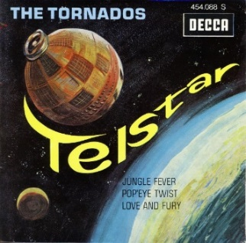
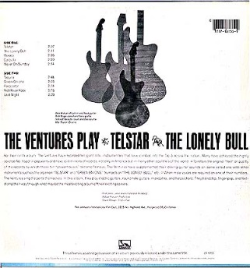
The back cover should have:
- Back Cover Art
- The Track Listing
- The Band’s Name and Album Title Listed
- All ten tracks and a minimum of a three sentence explanation of how it relates to the 1950s
Album Art | Work Ethic | Creativity | Explanations | Rating
Well done, has color, has all 6 items labeled. | Worked well; no reminders. | Catchy titles, fun to look at, 100% effort. | Explains all 10 songs in at least 3 sentences. | 10
Missing some labels, has color, but missing some of the six labels. | Has to be reminded more than twice. | Missing some items, borrowed some ideas from other albums. | A few explanations do not meet three sentences. | 8
No color, possibly missing labels. | Is off-task and has to be reminded several times. | ½ effort into project, resembles albums from other bands. | Most explanations do not make sense or do meet requirements. | 5
Very minimal effort; no color, missing almost all labels. | Unfocused; has to be consistently monitored for off-task behavior | Minimal effort; lacks creativity and subject knowledge. | Minimal effort; missing components; does not follow directions on nearly all explanations. | 3
No album submitted for a grade. | Completely unfocused; poor work ethic. | No effort made to make album look authentic. | Incomplete or no work submitted for a grade. | 0
 |  |  |  | Total: ____/40

